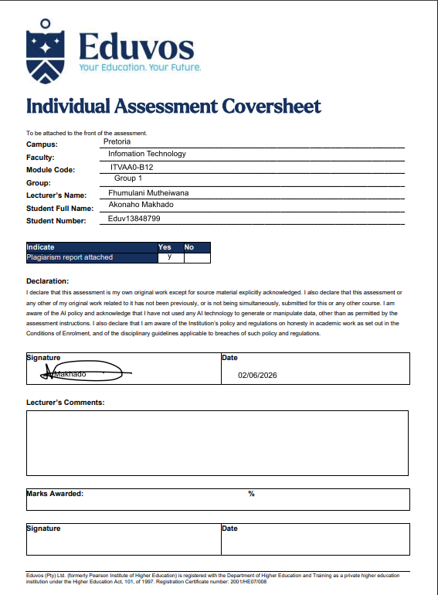

Acknowledgement
I would like to formally acknowledge the invaluable support and contributions that made the successful completion of this project possible.
I extend my sincere gratitude to the academic staff and lecturers at Eduvos, whose guidance, constructive feedback, and commitment to academic excellence provided the foundation for this work. Their mentorship ensured that the project was completed in accordance with academic standards and professional expectations.
I would also like to express my appreciation to my peers and colleagues for their collaboration, insightful discussions, and willingness to share resources throughout the duration of this project. Their contributions helped strengthen the quality of the research, refine the analysis, and enhance the overall outcomes.
Special thanks are extended to Fhumulani Mutheiwana for her continuous guidance, assistance, and support throughout every stage of the project. Her willingness to share knowledge, provide direction, demonstrate procedures, and offer encouragement played a significant role in the successful completion of this work. Her mentorship and dedication were invaluable throughout the research, implementation, and documentation processes.
I am equally grateful to my family and close supporters for their encouragement, patience, and unwavering motivation. Their belief in my academic journey provided the inspiration and determination needed to successfully complete this project.
I also acknowledge the valuable academic resources and guidance obtained through research conducted at Tshwane University of Technology (TUT). The additional resources and academic perspectives contributed significantly to expanding the scope and quality of this project.
Furthermore, I would like to express my sincere appreciation to A. Mudau, a member of the Council for Scientific and Industrial Research (CSIR), for providing professional guidance and support during the structuring and development of this project. His expertise and recommendations were instrumental in strengthening both the technical and analytical aspects of the work.
Finally, I acknowledge the frameworks, tools, and platforms that enabled the practical implementation of this project. These include Oracle VirtualBox, Windows 11, Ubuntu 26.04 LTS, and supporting administrative utilities such as Command Prompt, PowerShell, and the Linux Terminal, all of which played an essential role in the successful execution of the required tasks.
This acknowledgement serves as a testament to the collective effort, guidance, and support of all those who contributed to the academic and professional success of this project. Their contributions are sincerely appreciated and gratefully acknowledged.

Abstract
This project demonstrates the practical application of virtualization and cross-platform system administration within a simulated IT support environment. Oracle VM VirtualBox was used to create and manage virtual machines running Windows and Ubuntu Linux, enabling the replication of a real-world enterprise IT infrastructure within a controlled laboratory setting.
The primary focus of the project was to develop and apply essential CompTIA A+ aligned competencies, including system installation and configuration, end-user support documentation, hardware and software inventory analysis, and basic system troubleshooting. Emphasis was also placed on the development of standard operating procedures (SOPs) to support consistent IT support practices in a professional environment.
In addition, the project explored key operational tasks such as file system navigation, directory management, software installation, and system maintenance across both Windows and Linux platforms. These tasks reinforced an understanding of how hybrid environments function in modern organizations where multiple operating systems must be supported simultaneously.
The findings of this project demonstrate that virtualization is an effective method for simulating enterprise IT environments for training and skills development. Furthermore, the results highlight the importance of foundational IT support skills in maintaining system performance, ensuring operational efficiency, and supporting users within hybrid infrastructures.
Overall, the project confirms that structured IT support practices combined with virtualization technologies provide a strong foundation for meeting CompTIA A+ objectives and preparing for real-world IT support roles.

Executive Summary
Executive Summary
Modern organizations increasingly operate in mixed-platform environments where IT support staff are required to work effectively across both Windows and Linux systems. This report focuses on the standardization of IT operational procedures aimed at improving service delivery, technical documentation, and troubleshooting efficiency within a simulated enterprise environment. The project demonstrates how structured and consistent IT support practices can enhance system reliability, improve end-user assistance, and reduce unnecessary technical escalations while aligning with CompTIA A+ principles.
Virtualization was used as the primary method to simulate a real-world corporate IT infrastructure. Oracle VM VirtualBox was implemented to create and manage virtual machines representing typical workplace systems. A Windows 10/11 host environment was used to run virtual machines, including Windows-based workstations for productivity testing, system analysis, and performance evaluation, as well as an Ubuntu-based workstation for basic system administration, command-line operations, and software management. This approach provided a safe and controlled environment to replicate enterprise-level IT operations without impacting physical hardware.
A key outcome of the project was the development of structured documentation in the form of a Knowledge Base article designed to assist end-users in managing browser cache and cookies. This initiative promotes self-service support by enabling users to resolve common issues independently, thereby reducing the number of support tickets and improving overall IT service efficiency. In addition, system health and hardware inventory analysis was conducted using native Windows tools to evaluate CPU, memory, and storage performance against Windows 11 requirements. The findings helped identify system limitations and provided recommendations for potential hardware upgrades aimed at improving performance and reducing latency.
The project also included practical Linux administration tasks performed on an Ubuntu virtual machine. These tasks involved file system navigation, directory structure management, and file permission configuration using the command-line interface. Additional activities included package management, software installation, and service verification, including the configuration and validation of essential services such as SSH. These exercises strengthened foundational Linux administration skills required in modern IT environments. Furthermore, Windows troubleshooting and performance analysis were conducted to identify boot and application performance issues, ensuring that business applications operate efficiently without excessive resource consumption.
Overall, the completion of these activities demonstrates that standardized IT operational procedures, supported by proper documentation and cross-platform system administration, are both scalable and effective in a simulated enterprise environment. The project highlights how these practices contribute to improved system uptime, reduced support costs, and increased operational efficiency, reinforcing their importance in modern IT service delivery environments.

Table of Contents
1
Acknowledgement 2
Abstract 3
Executive Summary 4
Introduction 12
Section 1: Virtualisation Software Installation 13
Step 1: Download and Install Oracle VirtualBox 13
Section 1.1: Operating System Preparation – ISO Download 14
Step 1.1: Downloading Windows 11 ISO 14
Section 2: Virtual Machine Creation 15
Step 2: Starting a New Virtual Machine 15
Section 3: Virtual Machine Setup – Windows 11 15
Step 3: Configuring VM 01 15
Section 4: Unattended Installation Setup – VM 01 17
Step 4: Configuring Installation Parameters 17
Section 5: Resource Allocation – VM 01 18
Step 5: Configuring Virtual Hardware 18
Section 6: Storage Configuration – VM 01 19
Step 6: Configuring Virtual Hard Disk 19
Section 7: VM Creation Completed 21
Step 7: Finalizing VM Setup 21
Section 8: Operating System Installation – VM 1 23
Step 8: Booting the Virtual Machine 23
Section 9: Operating System Installation – VM 1 24
Step 9: Installing Windows 11 24
Section 11: Operating System Installation – VM 1 25
Step 9: Windows Login Screen 25
Section 10: User Account Integration – VM 1 26
Step 10: Logging in and Linking Student Account 26
Section 11: System Configuration – Firewall Setup 28
Step 11: Accessing Windows Defender Firewall 28
Section 12: Firewall Status – VM 1 29
Step 12: Viewing Firewall Settings 29
Section 13: Firewall Rule Configuration – VM 1 31
Step 13: Accessing Advanced Firewall Settings 31
Section 14: Custom Firewall Rule Management – VM 1 33
Step 14: Reviewing Inbound Rules 33
Section 15: Custom Firewall Rule Creation – VM 1 34
Step 15: Creating a New Inbound Rule 34
Section 16: Disk Management – Shrink Volume 36
Step 16: Shrinking the Windows (C:) Partition 36
Section 17: Partition Adjustment – Shrink Volume 38
Step 17: Shrinking C: Drive 38
Section 18: Command Line Access – VM 1 39
Step 18: Opening Command Prompt 39
Section 19: Command Line Administration – Network Test 39
Step 19: Checking Network Settings 39
Section 2: Operating System Preparation – Ubuntu ISO Download 41
Step 1: Downloading Ubuntu ISO 41
Section 2: Virtual Machine Overview – Ubuntu VM 43
Step 3: VM 2 Setup 43
Section 3: Ubuntu VM – Boot Process 45
Step 3: Starting Ubuntu VM 45
Section 4: Ubuntu Installation – Begin Setup 46
Step 4: Installing Ubuntu 46
Section 5: Ubuntu Installation – Language & Keyboard Setup 46
Step 5: Selecting Language and Keyboard Layout 46
Section 6: Ubuntu Installation – Installation Type 48
Step 6: Choosing Installation Type 48
Section 7: Ubuntu Installation – Disk Setup 49
Step 7: Installation Method 49
Section 8: Ubuntu Installation – User Account Setup 50
Step 8: Creating User Account 50
Section 9: Ubuntu Installation – Timezone Selection 51
Step 9: Setting Timezone and Location 51
Section 10: Ubuntu Installation – Copying Files 52
Step 10: Installation Progress 52
Section 11: Ubuntu Installation – Review & Finalize 53
Step 11: Reviewing Installation Choices 53
Section 12: Ubuntu Installation – Reboot and Desktop Access 55
Step 12: Restarting the System 55
Section 13: Ubuntu Installation – First Login 55
Step 13: Logging In 55
Section 14: Ubuntu Installation – Desktop Access 57
Step 14: Successful Login 57
Section 16: Ubuntu Installation – System Verification Complete 58
Step 16: Testing Commands 58
Question 1: Knowledge Base Article Creation 60
1.1 Standardised User Documentation 61
1.2 Knowledge Base (KB) Article 62
Question 2: Inventory Analysis and Upgrade Recommendation 66
Step 1: Preliminary Performance Overview 67
Step 2: Real-Time Performance Analysis 71
Question 3: Linux Directory Organisation 75
3.1: Linux Directory Manipulation & Verification 76
1. Command Sequence 76
2. Technical Justification (Marks Logic) 76
3. Verification of Results 78
4. Visual Evidence & Verification (CLI vs GUI) 79
Question 4: Linux Package Installation and Service Verification 83
1. Document the command used for installation. 84
Linux Package Installation and Service Verification 84
2. Viewing SSH Service Status 95
Question 5: Windows Performance and Startup Analysis 105
System Startup Behaviour and Performance Analysis 105
Identification 114
Explanation 114
Demonstration of Resource Interaction 114
References 117

Introduction
The IT business has had a lot of changes in the way they support their companies, including virtualizing and successfully managing different operating systems and technologies. As companies continue to grow, it will be imperative that they process and formalize the way they troubleshoot technical issues, rather than use the informal mechanisms of "flight or fight," in order to minimize downtime and provide their users with consistent services.
This assignment simulates the role of a Junior IT Operations Technician attempting to create an organization’s technical process formalization through the use of virtualization technology, providing both operating environments (Windows and UNIX) using VMware products, thereby demonstrating many CompTIA A+ objectives. In completing this task, this individual will create formal end-user documentation, perform administration at the command line of the UNIX operating system, and analyze the organization's systems in order to assist with hardware decisions.
In the subsequent sections of this document, the technical work and rationale necessary to assist in moving a new organization to a high-quality and structured IT support system will be outlined.

1. Host Machine: A functional Windows Operating System (Windows 10 or 11), which will run the virtualization software.
VM 1: A Windows 10 or Windows 11 VM

Section 1: Virtualisation Software Installation

Step 1: Download and Install Oracle VirtualBox
I have downloaded and installed Oracle VirtualBox, which is an extremely popular open-source virtual machine application. This application allows users to create and run many different kinds of VMs on just one host computer, using either Windows or Linux OS.
I chose this software because it supports the objectives outlined in CompTIA A+ 220 1202 and offers a reliable area for performing tests and configuration jobs.
Evidence (Screenshot Provided):
- The screenshot shows Oracle VirtualBox successfully installed and accessible from the Windows search interface.
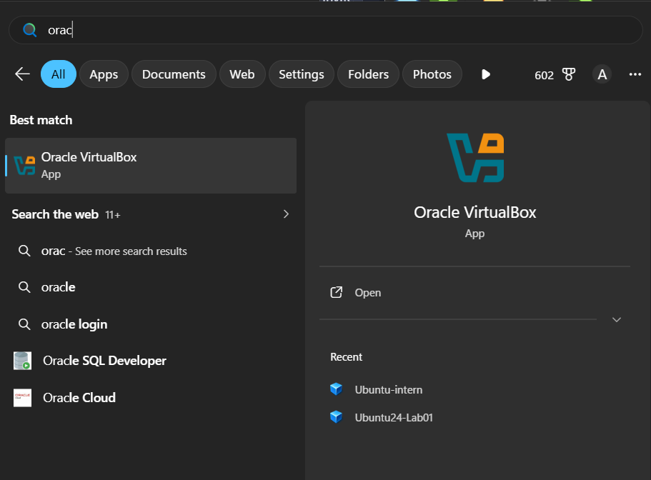

Evaluation:
- Installing VirtualBox is a critical prerequisite for the project, as it provides the virtualization layer required to run both Windows and Linux VMs.
- This step ensures the host machine (Windows 10/11) is properly equipped to support the project’s technical objectives.

Section 1.1: Operating System Preparation – ISO Download

Step 1.1: Downloading Windows 11 ISO
- Before installing Windows 11 in the VM, I downloaded the official installation file.
- The file name was Win11_25H2_English_x64_v2.iso.
- The download progress showed 4.7 GB of 7.9 GB completed, confirming the ISO was being retrieved successfully.
Evidence (Screenshot Provided):
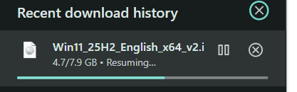
- The download window shows the ISO file in progress.
- This proves the operating system image was obtained and prepared for use in VirtualBox.
Evaluation:
- Downloading the ISO is a critical prerequisite for VM setup.
- It ensures the VM can boot and install Windows 11 properly.
- This step validates that the environment was prepared correctly before installation.

Section 2: Virtual Machine Creation

Step 2: Starting a New Virtual Machine
- In Oracle VirtualBox Manager, I pressed the blue “New” button to begin creating a new virtual machine.
- This initiated the VM setup wizard, allowing me to specify the name, operating system type, and hardware resources for the new environment.

Evidence (Screenshot Provided):
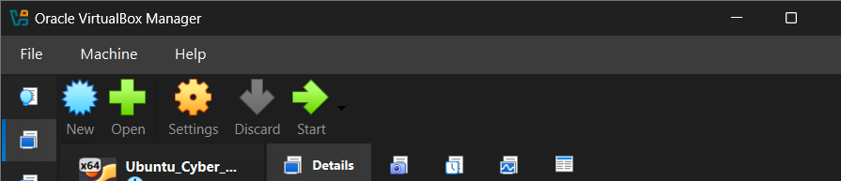
- This confirms that the VM creation process was successfully initiated and saved.
Evaluation:
- Creating VM 1 establishes the Windows environment required by the project brief.
- This step demonstrates the ability to allocate system resources (CPU, RAM, disk space) and configure essential components such as storage controllers and network adapters.
- VM creation is a critical milestone because it provides the isolated environment where all Windows-based configuration tasks will be performed.

Section 3: Virtual Machine Setup – Windows 11

Step 3: Configuring VM 01
- I created a new virtual machine named “VM 01”.
- The VM folder was set to: C:\Users\Akonaho\VirtualBox VMs — this ensures all VM files are stored in a dedicated directory for easy management.
- The installation ISO selected was: Win11_25H2_English_x64_v2.iso, which contains the Windows 11 Home edition installer.
- Operating System details:
  - OS Edition: Windows 11 Home (10.0.26200.8037 / x64 / en-US)
  - OS Type: Microsoft Windows
  - OS Version: Windows 11 (64-bit)
Unattended Installation:
- The option “Proceed with Unattended Installation” was enabled.
- This feature allows VirtualBox to automatically handle installation prompts (like username, password, product key, and regional settings), speeding up the setup process.
Evidence (Screenshot Provided):
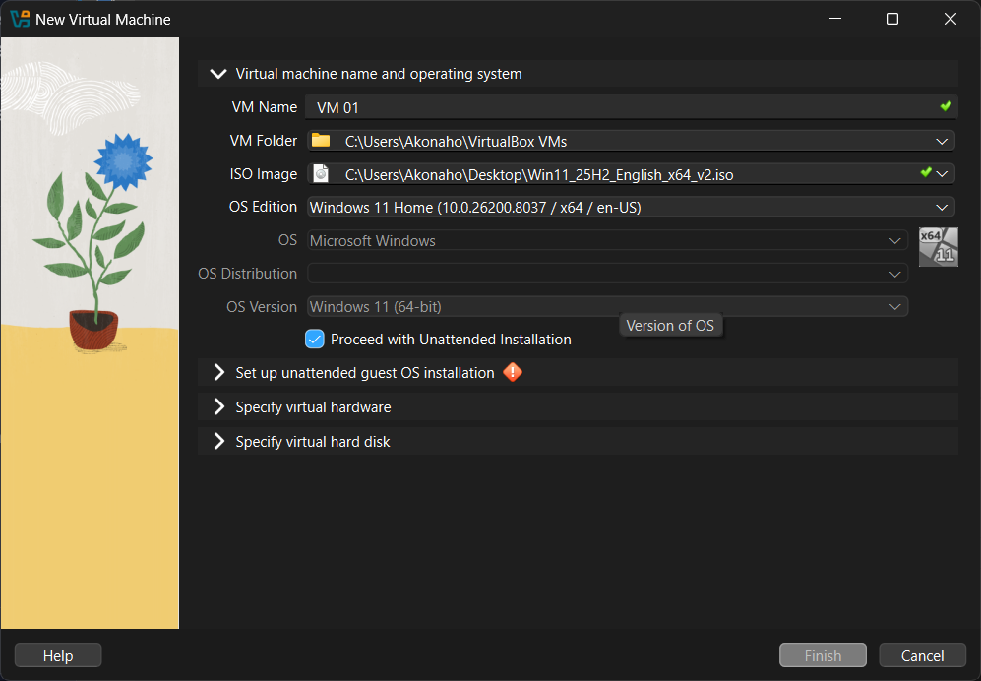
- The wizard clearly shows the VM name, ISO path, OS edition, and unattended installation option selected.
- This confirms that the VM is properly configured to begin the Windows 11 installation process.
Evaluation:
- Choosing Windows 11 Home aligns with the project requirement to create a Windows VM.
- Using an ISO ensures a clean installation environment.
- Enabling unattended installation demonstrates efficiency and automation in system setup, which is a key virtualization skill.

Section 4: Unattended Installation Setup – VM 01

Step 4: Configuring Installation Parameters
- During the VM creation process, I enabled Unattended Guest OS Installation.
- This feature allows VirtualBox to automatically complete the Windows installation without requiring manual input for each step.
Configuration Details:
- User Credentials:
  - Username: vboxuser
  - Password: Password (entered and confirmed)
- System Identity:
  - Host Name: VM1
  - Domain Name: myguest.virtualbox.org
- Guest Additions:
  - Selected ISO: VBoxGuestAdditions.iso
  - Purpose: Provides enhanced integration features such as shared clipboard, drag-and-drop, and improved display drivers.
Evidence (Screenshot Provided):
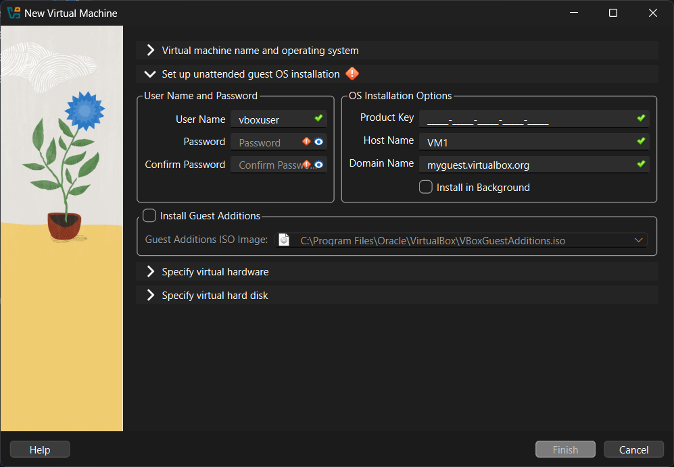
- The wizard clearly shows the username, password, host name, and domain name fields filled in.
- The Guest Additions ISO path is specified, confirming that integration tools will be installed alongside the OS.
Evaluation:
- Automating the installation process saves time and ensures consistency across VM setups.
- Defining credentials and host/domain names demonstrates proper system configuration practices.
- Including Guest Additions enhances usability, making the VM more responsive and better integrated with the host system.

Section 5: Resource Allocation – VM 01

Step 5: Configuring Virtual Hardware
- I specified the hardware resources for the new virtual machine to ensure stable performance while balancing host system capacity.
Configuration Details:
- Base Memory (RAM): 4096 MB (4 GB)
  - Allocating 4 GB ensures Windows 11 can run smoothly with basic applications, while leaving sufficient memory for the host system.
- Number of CPUs: 2
  - Assigning 2 virtual CPUs provides multitasking capability without overloading the host machine.
- EFI Enabled: Checked
  - EFI (Extensible Firmware Interface) is required for modern operating systems like Windows 11, ensuring compatibility with secure boot and advanced hardware features.
- Virtual Hard Disk: To be specified in the next step (e.g., 80 GB dynamically allocated).
Evidence (Screenshot Provided):
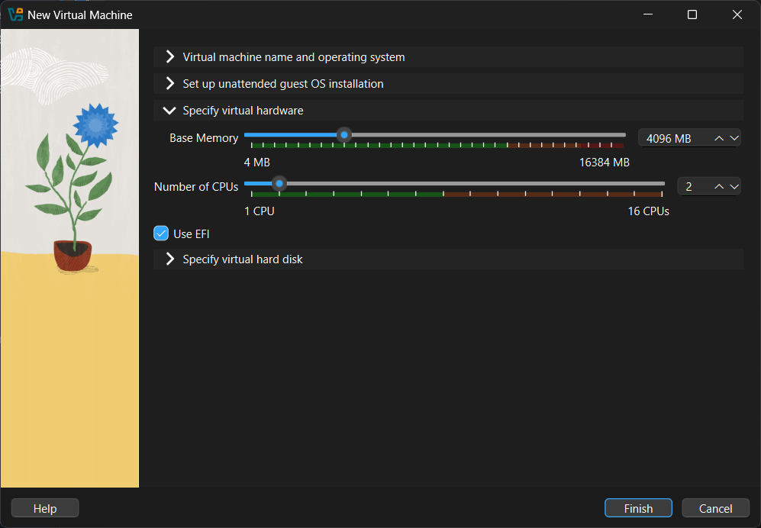
- The wizard shows sliders set to 4096 MB RAM and 2 CPUs, with EFI enabled.
- This confirms that the VM has been provisioned with adequate resources for installation and operation.
Evaluation:
- Allocating resources is a critical step in virtualization, as it directly impacts VM performance.
- The chosen values balance efficiency and host system stability, demonstrating proper resource management.
- Enabling EFI ensures the VM is future-proof and aligned with modern OS requirements.

Section 6: Storage Configuration – VM 01

Step 6: Configuring Virtual Hard Disk
- I selected the option to Create a New Virtual Hard Disk for VM 01.
- File Location: C:\Users\Akonaho\VirtualBox VMs\VM 01\VM 01.vdi
- Disk Size: 80 GB (dynamically allocated)
  - This size is sufficient for Windows 11 installation, updates, and basic applications.
- File Type: VDI (VirtualBox Disk Image)
  - Chosen for compatibility and flexibility within VirtualBox.
- Pre-allocate Full Size: Not selected, allowing dynamic disk growth to save host storage space.
- Split Disk Into 2 GB Parts: Not selected, keeping the disk file unified for easier management.
Evidence (Screenshot Provided):
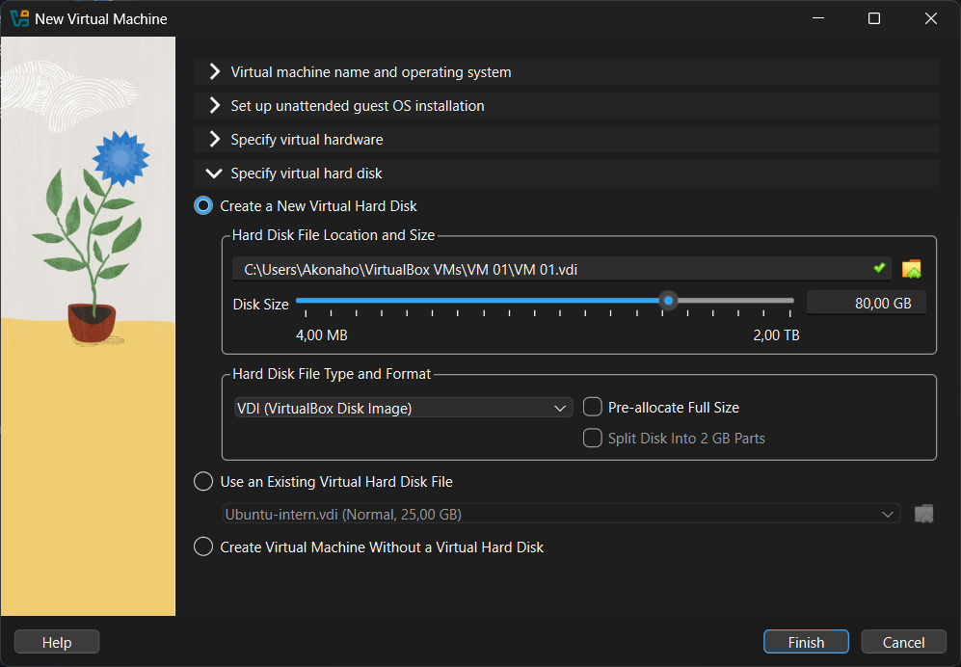
- The wizard shows the disk size set to 80 GB, file type as VDI, and storage path correctly defined.
- This confirms the VM has a dedicated virtual hard disk ready for installation.
Evaluation:
- Allocating 80 GB balances performance and storage efficiency.
- Dynamic allocation ensures the VM only uses physical disk space as needed.
- Choosing VDI format aligns with VirtualBox’s native disk management, simplifying backups and portability.

Section 7: VM Creation Completed

Step 7: Finalizing VM Setup
- After pressing Finish, the virtual machine VM 01 was successfully created.
- VM 01 now appears in the VirtualBox Manager list, ready for operating system installation and configuration.
Evaluation:
- Completing this step establishes the Windows 11 VM environment required by the project brief.
- The VM is now prepared for practical tasks such as OS installation, configuration, and troubleshooting.

Section 7: Completed Virtual Machine – VM 1 (Windows 11)
General Configuration:
- Name: VM 1
- Operating System: Windows 11 (64-bit)
Display Settings:
- Video Memory: 128 MB
- Graphics Controller: VMSVGA
- Remote Desktop Server: Disabled
- Recording: Disabled
Storage Setup:
- Controller: SATA
- SATA Port 0: VM 1.vdi (Normal, 80 GB)
- SATA Port 1: Optical Drive (Windows 11 ISO attached for installation)
Audio Settings:
- Host Driver: Default
- Controller: Intel HD Audio
Network Configuration:
- Adapter 1: Intel PRO/1000 MT Desktop (NAT)
  - NAT mode allows the VM to access the internet through the host system while remaining isolated for security.
Other Settings:
- USB: None
- Shared Folders: None
- Description: None

Evidence (Screenshot Provided):
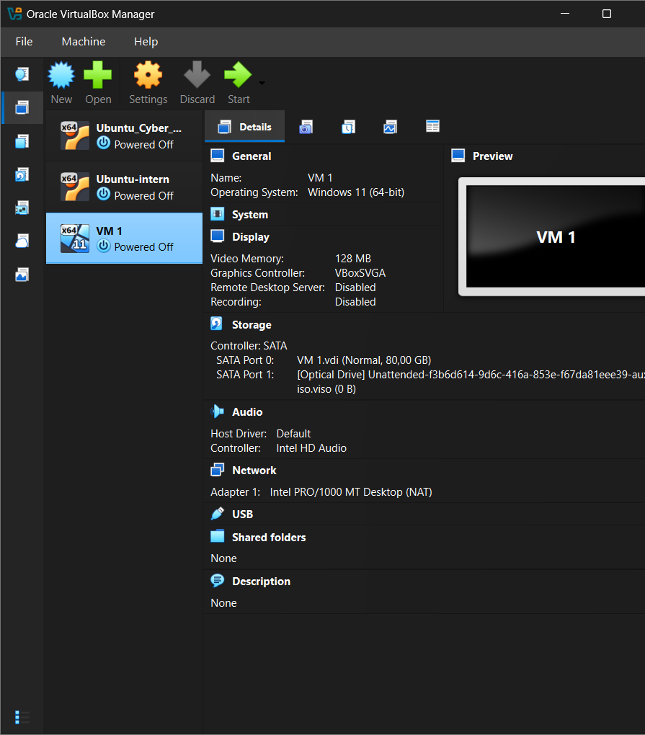
- The VirtualBox Manager shows VM 1 listed and powered off, with all configuration details displayed in the right panel.
- The storage section confirms the virtual hard disk (80 GB VDI) and Windows 11 ISO are correctly attached, meaning the VM is ready for OS installation.
Evaluation:
- VM 1 has been successfully created and configured to meet the project requirement of a Windows virtual machine.
- The chosen settings (RAM, CPU, disk size, NAT networking) balance performance and host system stability.
- This VM is now prepared for the next stage: Windows 11 installation and configuration tasks

Section 8: Operating System Installation – VM 1

Step 8: Booting the Virtual Machine
- After pressing on VM 1 in VirtualBox Manager, the system begins the startup process.
- The VirtualBox loading screen appears, confirming that the virtual machine is initializing and preparing to boot from the attached Windows 11 ISO.
Evidence (Screenshot Provided):
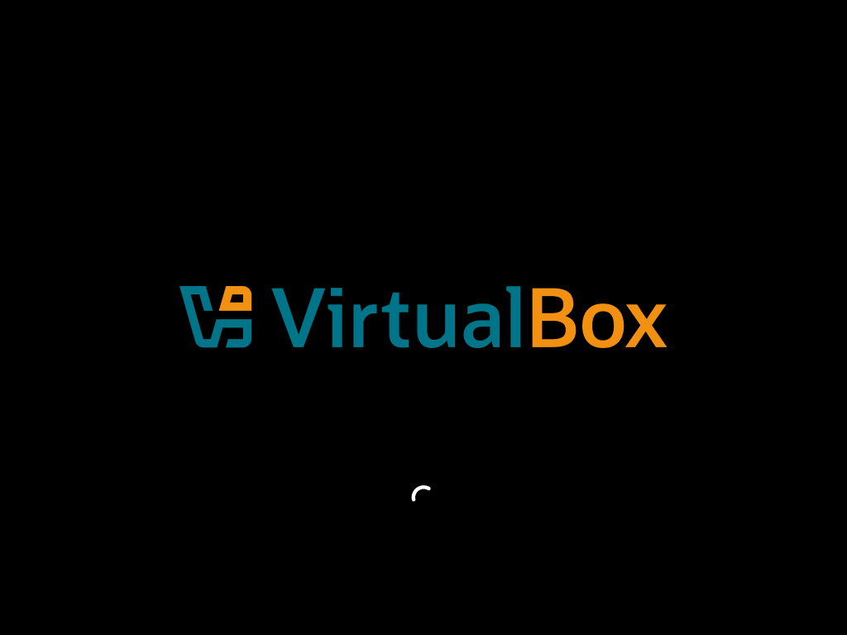
- The VirtualBox logo and loading indicator are displayed, showing that VM 1 has successfully entered the boot sequence.
- This verifies that the VM is correctly linked to the installation media and ready to proceed with the Windows 11 setup.
Evaluation:
- Booting the VM is a critical step, as it transitions from configuration to actual operating system installation.
- The successful startup demonstrates that the hardware resources (RAM, CPU, disk, graphics controller) and storage configuration (ISO + VDI) were correctly defined during setup.
- This stage confirms readiness for the next phase: Windows installation wizard and unattended setup execution

Section 9: Operating System Installation – VM 1

Step 9: Installing Windows 11
- After starting VM 1, the system booted from the attached Windows 11 ISO and began the installation process.
- The installation wizard displayed progress with the message: “Installing Windows 11 – Your PC will restart several times. This might take a while.”
- At this stage, the installation was 18% complete, confirming that the OS setup was successfully underway.
Evidence (Screenshot Provided):
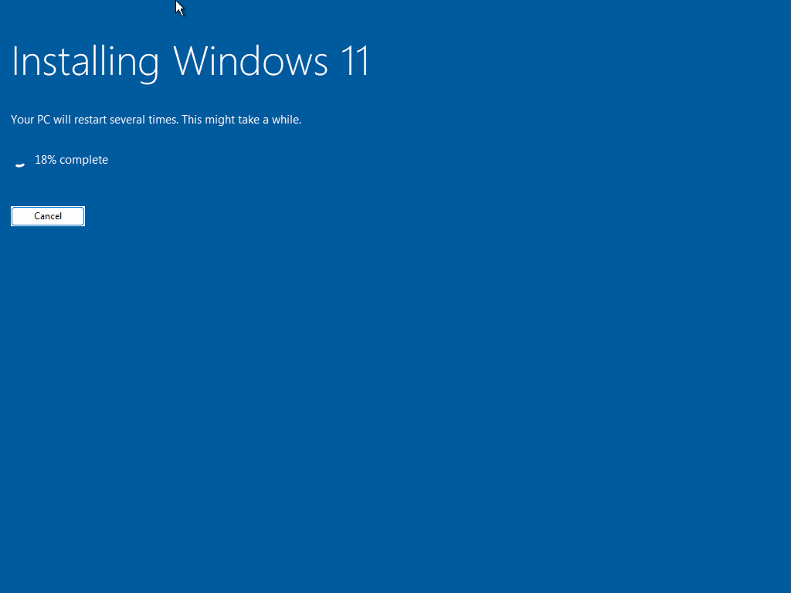
- The installation progress screen verifies that Windows 11 is being installed on VM 1.
- The restart notifications indicate that the unattended installation process is functioning as expected.
Evaluation:
- This step demonstrates that the VM is properly configured to boot from the ISO and install the operating system.
- The progress bar confirms that the installation is active, validating earlier configuration choices (RAM, CPU, disk size, EFI).
- Once completed, the VM transitions to the login stage, where the default user (vboxuser) is created.

Section 11: Operating System Installation – VM 1

Step 9: Windows Login Screen
- After the installation process completed, VM 1 booted into the Windows 11 login interface.
- The system displayed the default user account created during unattended installation: vboxuser.
- The “Welcome” message confirms that the operating system has successfully initialized and is ready for first-time use.
Evidence (Screenshot Provided):
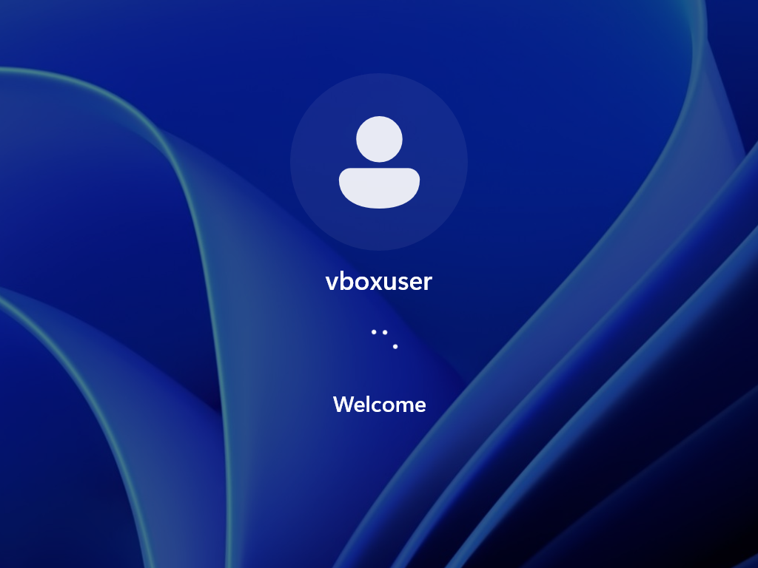
- The login screen shows the user account vboxuser with a welcome prompt.
- This verifies that the unattended installation was successful and the VM is now running Windows 11.
Evaluation:
- Reaching the login screen demonstrates that the VM creation, resource allocation, and installation steps were correctly executed.
- The presence of the vboxuser account confirms that the unattended setup applied the credentials defined earlier in the configuration wizard.
- This stage marks the transition from installation to system configuration and practical tasks (e.g., disk management, firewall rules, command execution).

Section 10: User Account Integration – VM 1

Step 10: Logging in and Linking Student Account
- After the Windows 11 installation completed, I logged in using the default account created during unattended setup: vboxuser.
- Once inside the system, I navigated to Settings → Accounts → Profiles.
- I then signed in with my student account (Eduvos email) to ensure synchronization of settings, access to Microsoft services, and proper personalization under my academic identity.
Evidence (Screenshot Provided):
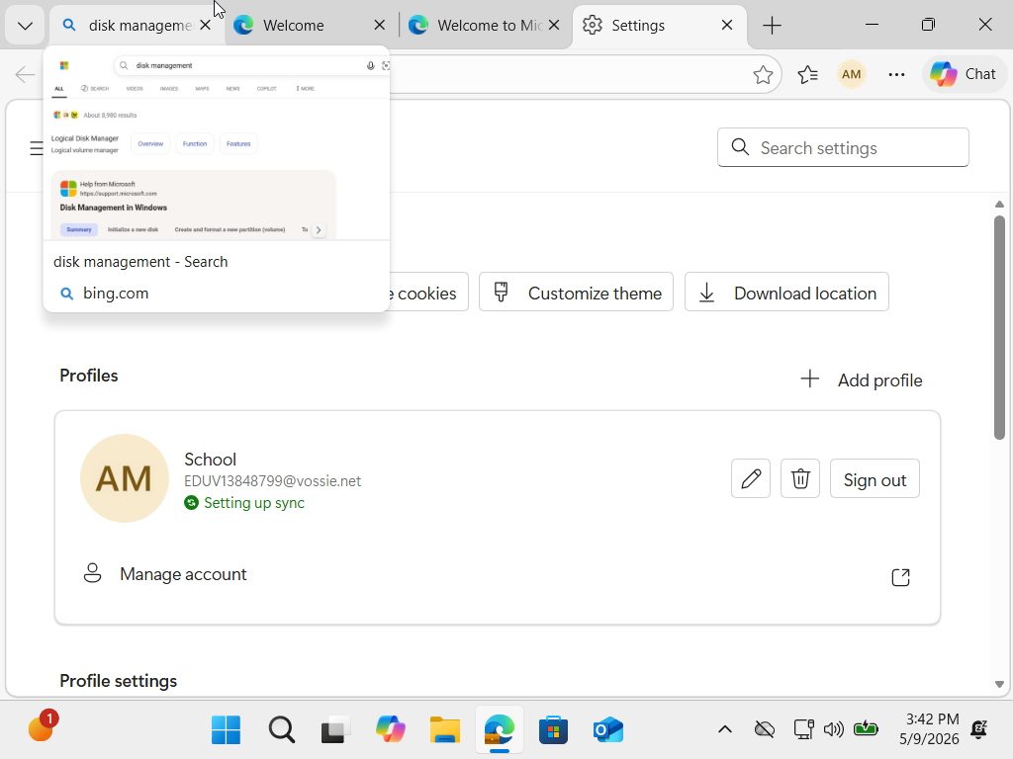
- The Settings window shows the profile section with the student account (EDUV13848799@vossie.net) being set up for sync.
- This confirms that the VM is now linked to my student credentials, ensuring the environment reflects my actual user identity rather than the default vboxuser.
Evaluation:
- Linking the student account ensures that the VM can run properly with personalized settings, access to cloud services, and integration with academic resources.
- This step demonstrates good practice in system setup: moving from a generic installation account to a real user profile for practical use.
- It also aligns with the project requirement to show configuration tasks performed inside the VM environment.

Section 11: System Configuration – Firewall Setup

Step 11: Accessing Windows Defender Firewall
- After logging in with my student account, I opened the Start menu search bar and typed “window def”.
- The best match result displayed was Windows Defender Firewall (Control Panel).
- Selecting this option allows me to configure firewall rules, which are essential for securing the VM environment and controlling network traffic.
Evidence (Screenshot Provided):
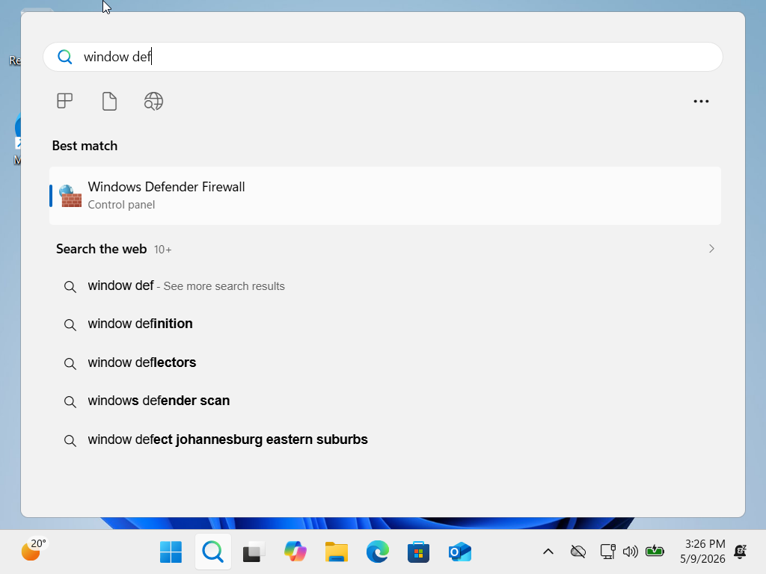
- The search interface shows “Windows Defender Firewall” as the best match.
- This confirms that the VM is running Windows 11 properly and that system security tools are accessible within the virtual environment.
Evaluation:
- Accessing Windows Defender Firewall is a critical configuration task, as it demonstrates the ability to manage system security inside the VM.
- This step aligns with the project requirement to perform practical tasks (like firewall rule creation) and provide screenshots as evidence.
- It also shows that the VM is functioning with full Windows features, ready for further configuration and troubleshooting.

Section 12: Firewall Status – VM 1

Step 12: Viewing Firewall Settings
- After searching for Windows Defender Firewall, I opened the Firewall control panel to review the current security status.
- The system displayed firewall information for both Private networks and Guest/Public networks.
- The active connection was identified as a public network, with the firewall turned On.
Configuration Details:
- Private Networks: Not connected
- Guest/Public Networks: Connected
  - Firewall State: On
  - Incoming Connections: Block all apps not on the allowed list
  - Active Public Network: Network
  - Notification State: Notify when a new app is blocked
Evidence (Screenshot Provided):
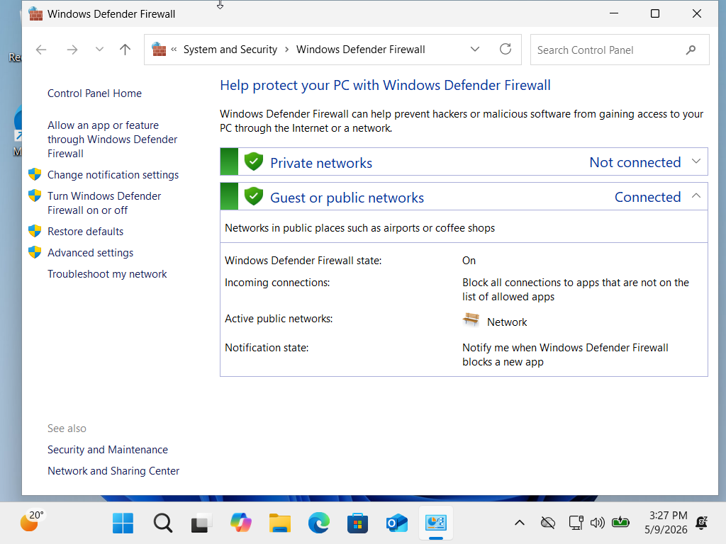
- The firewall window shows the active public network with protection enabled.
- This confirms that Windows Defender Firewall is running correctly inside VM 1 and is actively securing the environment.
Evaluation:
- Reviewing firewall status is a critical system configuration task, demonstrating awareness of network security within the VM.
- The settings confirm that the VM is protected against unauthorized inbound connections, aligning with best practices for secure system setup.
- This step provides clear evidence of security configuration, fulfilling part of the project’s marking criteria.

Section 13: Firewall Rule Configuration – VM 1

Step 13: Accessing Advanced Firewall Settings
- From the Windows Defender Firewall control panel, I selected Advanced Settings to open the Windows Defender Firewall with Advanced Security console.
- This interface provides detailed control over inbound and outbound rules, connection security, and monitoring.
Configuration Overview:
- Domain Profile:
  - Firewall: On
  - Inbound connections not matching a rule: Blocked
  - Outbound connections not matching a rule: Allowed
- Private Profile:
  - Firewall: On
  - Inbound connections not matching a rule: Blocked
  - Outbound connections not matching a rule: Allowed
- Public Profile (Active):
  - Firewall: On
  - Inbound connections not matching a rule: Blocked
  - Outbound connections not matching a rule: Allowed
Evidence (Screenshot Provided):
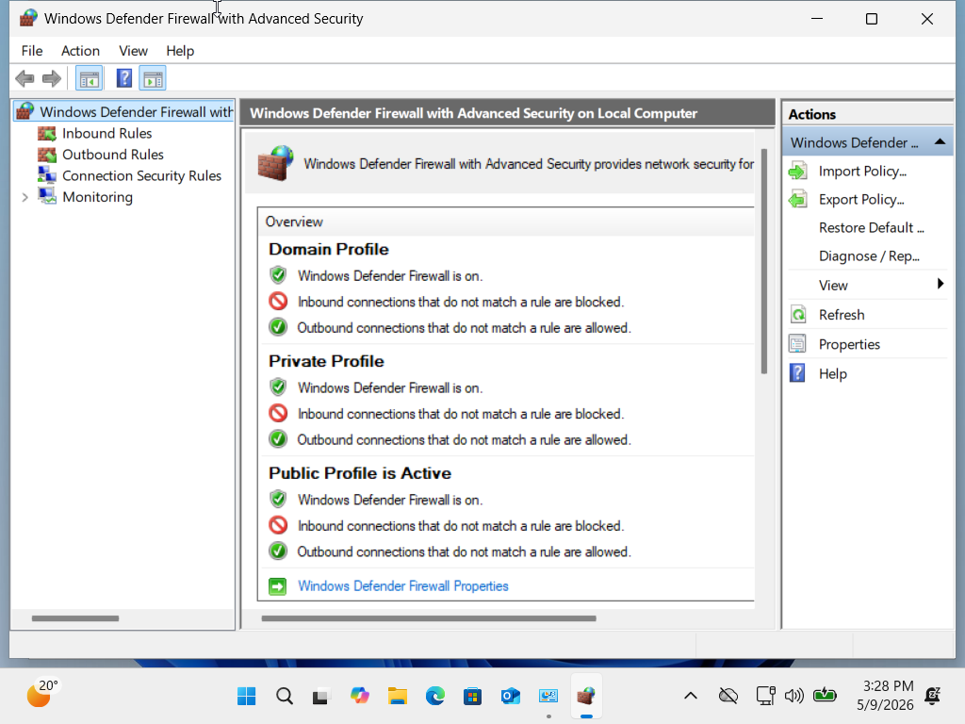
- The console shows all three profiles with firewall protection enabled.
- The active profile is Public, confirming that the VM is connected to a public network and is secured against unauthorized inbound traffic.
Evaluation:
- Accessing advanced firewall settings demonstrates the ability to manage system security at a granular level.
- The configuration ensures that the VM is protected across all network profiles, with strict inbound rules and controlled outbound traffic.
- This step aligns with the project requirement to show practical configuration tasks and provide evidence through screenshots.

Section 14: Custom Firewall Rule Management – VM 1

Step 14: Reviewing Inbound Rules
- From the advanced firewall console, I navigated to Inbound Rules to examine how incoming network traffic is controlled.
- The list displayed multiple predefined rules, including entries for system services and applications such as AllJoyn Router (TCP/UDP), App Installer, and Cast to Device functionality.
- Each rule specifies whether certain types of traffic are allowed or blocked, ensuring that only authorized connections reach the VM.
Evidence (Screenshot Provided):
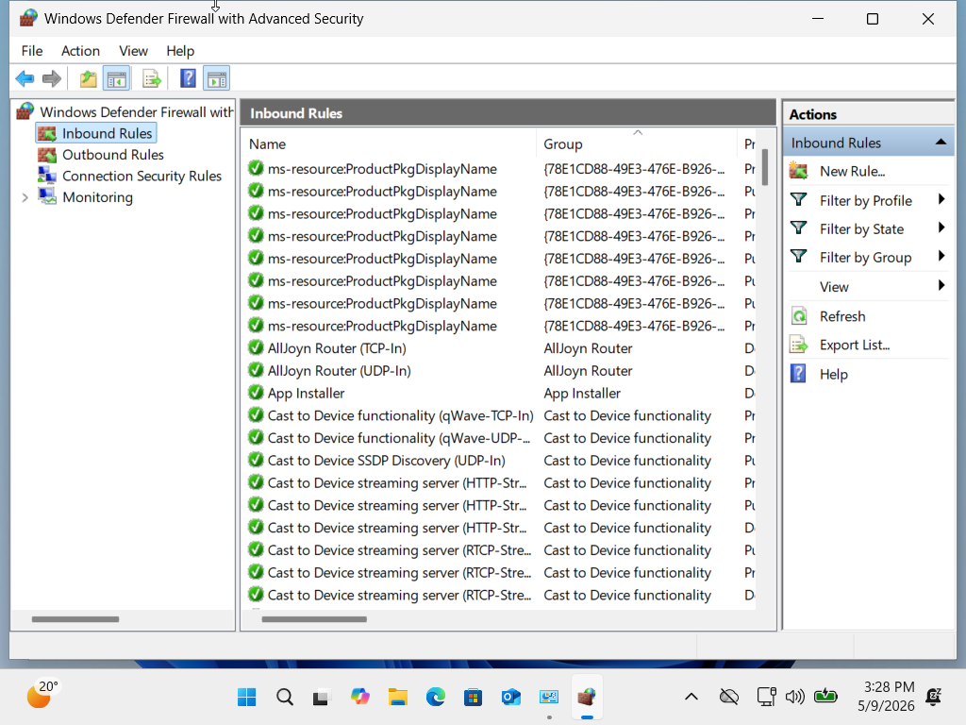
- The inbound rules list confirms that Windows Defender Firewall is actively managing incoming connections.
- The presence of multiple predefined rules demonstrates that the VM is protected by default configurations, which can be customized further.
Evaluation:
- Reviewing inbound rules is a critical step in system security management.
- It shows the ability to identify existing protections and prepare for custom rule creation (e.g., blocking a specific port or allowing a trusted application).
- This step aligns with the project requirement to demonstrate practical firewall configuration tasks inside the VM environment.

Section 15: Custom Firewall Rule Creation – VM 1

Step 15: Creating a New Inbound Rule
- I opened the New Inbound Rule Wizard in Windows Defender Firewall with Advanced Security.
- Rule Type: Selected Port, to control traffic through a specific TCP port.
- Protocol and Ports:
  - Protocol: TCP
  - Specific Local Port: 80 (commonly used for HTTP traffic)
- Action: Selected Block the connection, ensuring that any attempt to use port 80 is denied.
- Profile: Applied the rule to all profiles (Domain, Private, and Public) to ensure consistent protection across different network environments.
- Name: Entered “Project port 80 block” to clearly identify the rule.
Evidence (Screenshot Provided):
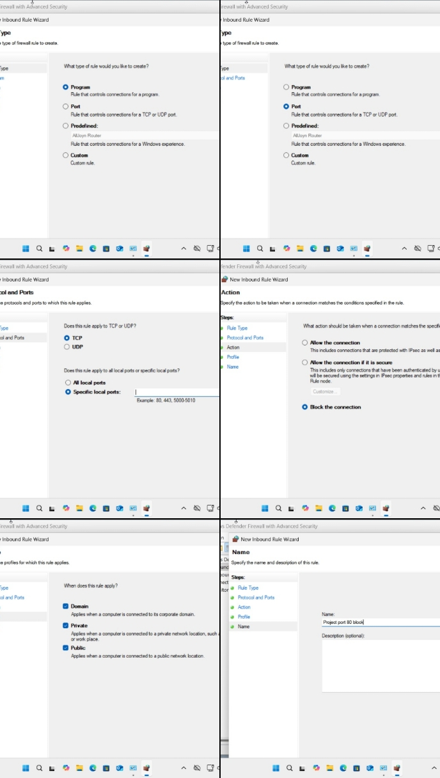
- The wizard shows the rule creation steps completed, with the final name “Project port 80 block.”
- This confirms that the inbound rule was successfully defined and saved.
Evaluation:
- Blocking port 80 demonstrates the ability to create custom firewall rules for enhanced security.
- This rule prevents unauthorized HTTP traffic from entering the VM, reducing exposure to potential web-based attacks.
- The step fulfils the project requirement to show practical firewall configuration and provides clear evidence of security management inside the VM.

Section 16: Disk Management – Shrink Volume

Step 16: Shrinking the Windows (C:) Partition
- I searched for Disk Management using the Start menu and opened the utility.
- From the list of available partitions, I selected the Windows (C:) drive.
- I then right-clicked on the C: partition to open the context menu.
- From the menu options, I chose Shrink Volume to reduce the size of the partition and free up unallocated space.
Evidence (Screenshot Provided):
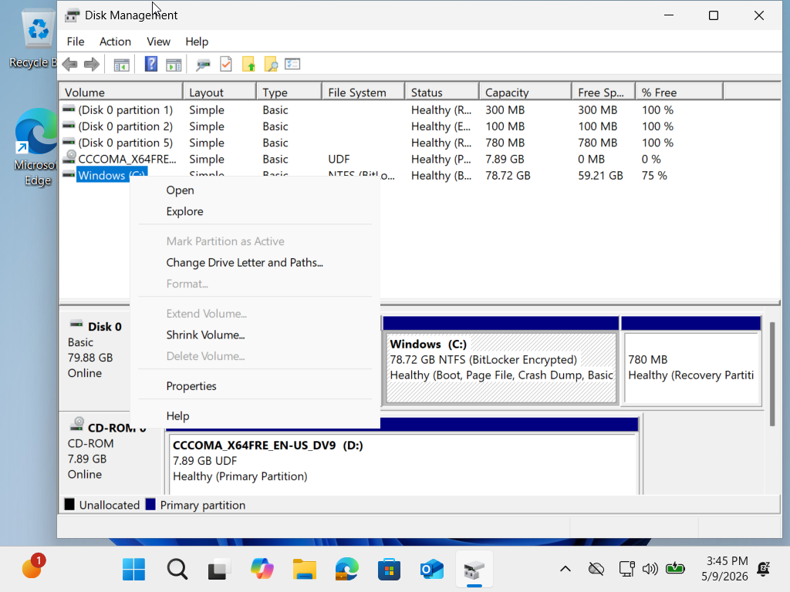
- The Disk Management window shows the C: partition highlighted with the right-click menu open.
- The presence of the Shrink Volume option confirms that the partition can be resized.
Evaluation:
- Shrinking the C: drive is a useful administrative task, allowing the creation of additional partitions for testing, backups, or dual-boot configurations.
- This demonstrates practical system management skills inside the VM, fulfilling the project requirement to show disk configuration tasks.
- The action also proves that the VM’s virtual hard disk is fully functional and manageable within Windows.

Section 17: Partition Adjustment – Shrink Volume

Step 17: Shrinking C: Drive
- I opened Disk Management.
- Selected Windows (C:) and right-clicked.
- Chose Shrink Volume.
- In the dialog box, I changed the shrink value from 58,651 MB to 2,048 MB.
- This reduced the C: drive by 2 GB and created unallocated space.
Evidence:
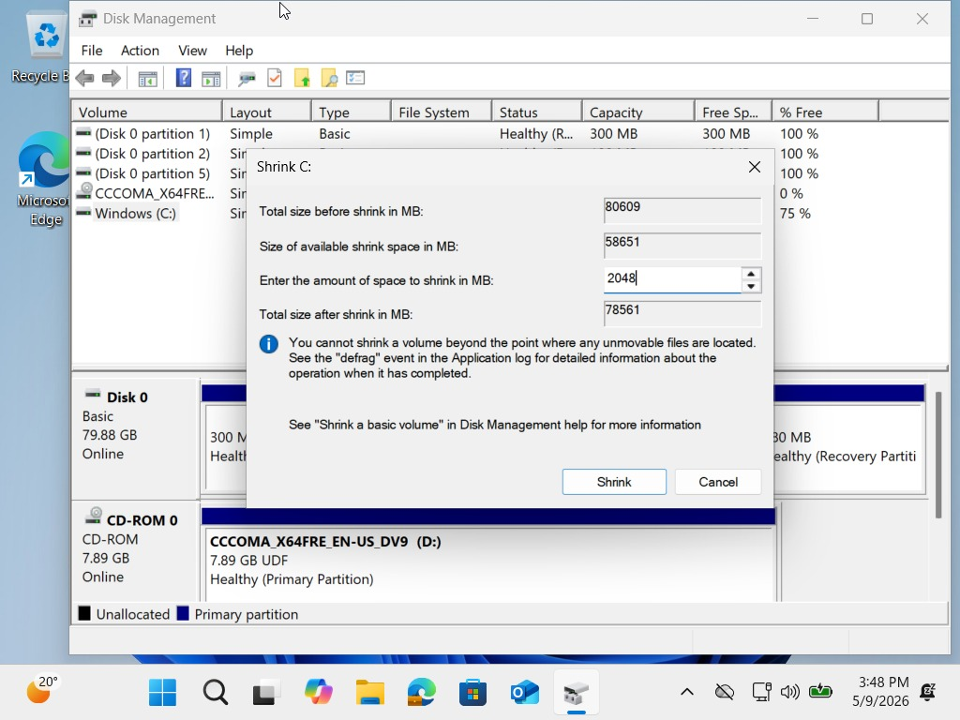
- The dialog shows the retyped value 2,048 MB.
Evaluation:
- Shrinking by 2 GB proves manual control of disk space.
- It created unallocated space for new partitions or testing.

Section 18: Command Line Access – VM 1

Step 18: Opening Command Prompt
- I searched cmd in the Start menu.
- Selected Command Prompt from the results.
- This opened the terminal for running system commands.
Evidence:

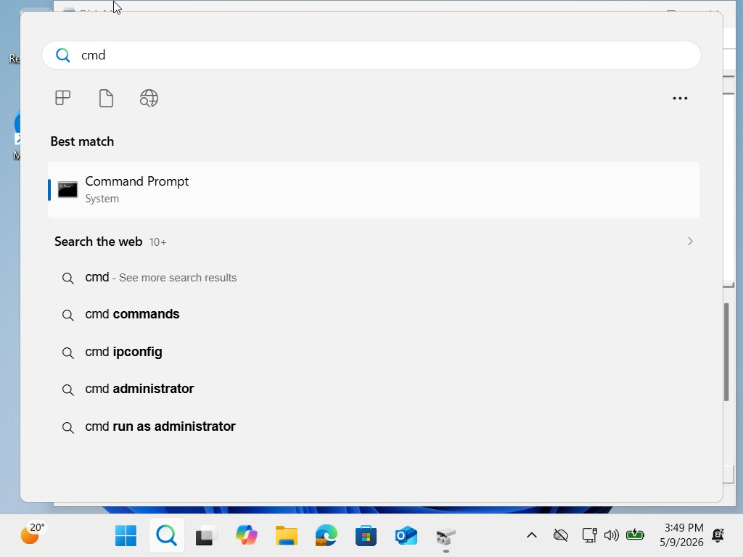
- The screenshot shows the search result with Command Prompt highlighted.
Evaluation:
- Accessing Command Prompt is essential for administrative tasks like checking system info, IP configuration, and running security commands.
- This step confirms the VM is ready for command-line operations.

Section 19: Command Line Administration – Network Test

Step 19: Checking Network Settings
- I opened Command Prompt.
- Ran ipconfig to view network details.
  - IPv4 Address: 10.0.2.15
  - Subnet Mask: 255.255.255.0
  - Default Gateway: 10.0.2.2
Step 20: Connectivity Test
- Entered ping 8.8.8.8 (Google DNS).
- Received 4 replies with times between 9–11 ms.
- No packet loss (Sent = 4, Received = 4, Lost = 0).
Evidence:
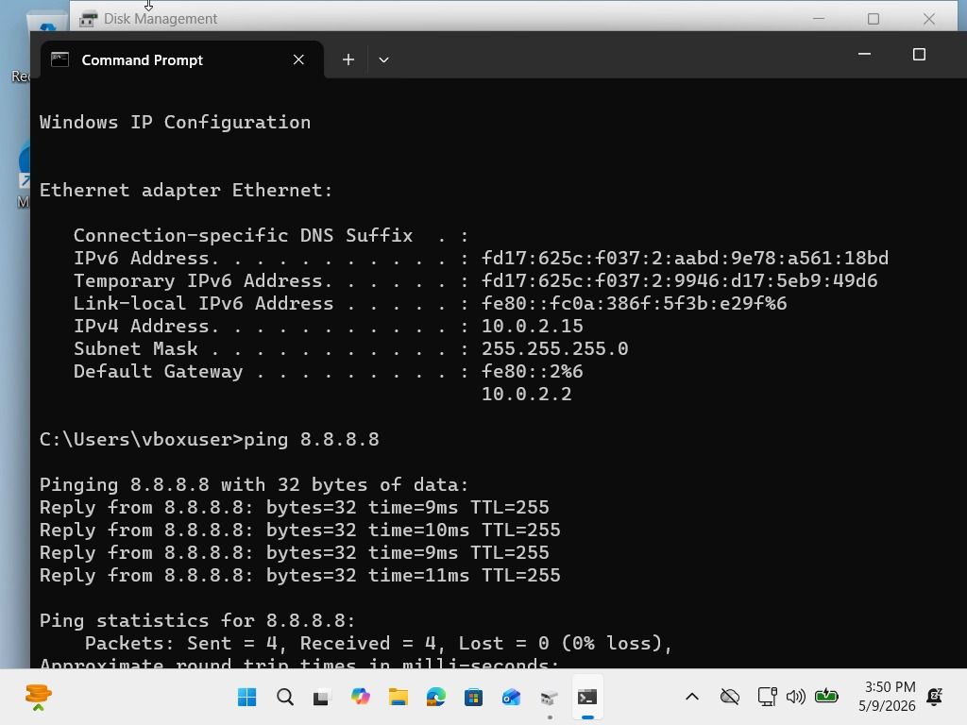
- Screenshot shows both ipconfig output and successful ping results.
Evaluation:
- The VM has a working network connection.
- Ping confirms external connectivity and low latency.
- This step proves the VM is properly configured for internet access.

- Virtual Machines (VMs): You must create and utilise two distinct virtual machines:
  - VM 2: A Linux VM (e.g., Ubuntu, Debian, or Mint, strictly adhering to CompTIA A+ 220-1202 objectives)
Here’s how to properly document this as Step 1 for your Linux VM setup:

Section 2: Operating System Preparation – Ubuntu ISO Download

Step 1: Downloading Ubuntu ISO
- I opened Google Chrome and searched for Ubuntu Desktop.
- Navigated to the official Ubuntu website.
- Selected the latest Ubuntu 26.04 LTS (Long Term Support) version.
- Downloaded the Intel/AMD 64-bit ISO file (5.9 GB) to prepare for installation in the VM.
Evidence (Screenshot Provided):
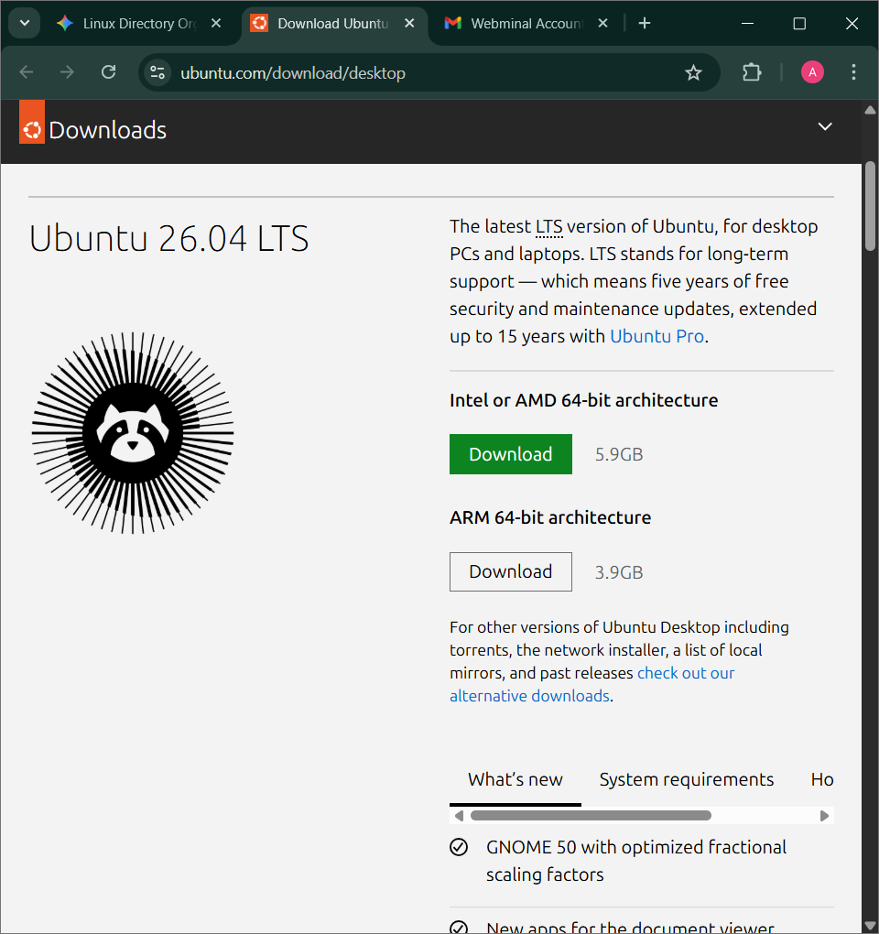
- The Ubuntu download page shows the LTS version with the download button highlighted.
- Confirms that the correct ISO file was obtained for installation.
Evaluation:
- Downloading the ISO is the first step in setting up the Linux VM.
- Ensures the environment is ready for installation and testing.
- Using the LTS version guarantees long-term stability and security updates.

Section 2: Virtual Machine Overview – Ubuntu VM

Step 3: VM 2 Setup
- In Oracle VirtualBox Manager, I created VM 2 for Ubuntu.
- The process was the same as VM 1 (Windows) — selecting ISO, naming the VM, and assigning hardware resources.
- The difference is that VM 2 focuses on Ubuntu (Linux) instead of Windows.
Configuration Details:
- VM Name: VM 2 (Ubuntu 64-bit)
- Storage: Ubuntu-intern.vdi, 25 GB
- Memory: 4096 MB
- Processor: 1
- Display: 128 MB video memory, VBoxVGA controller
- Network: NAT (Intel PRO/1000 MT Desktop)
Evidence (Screenshot Provided):
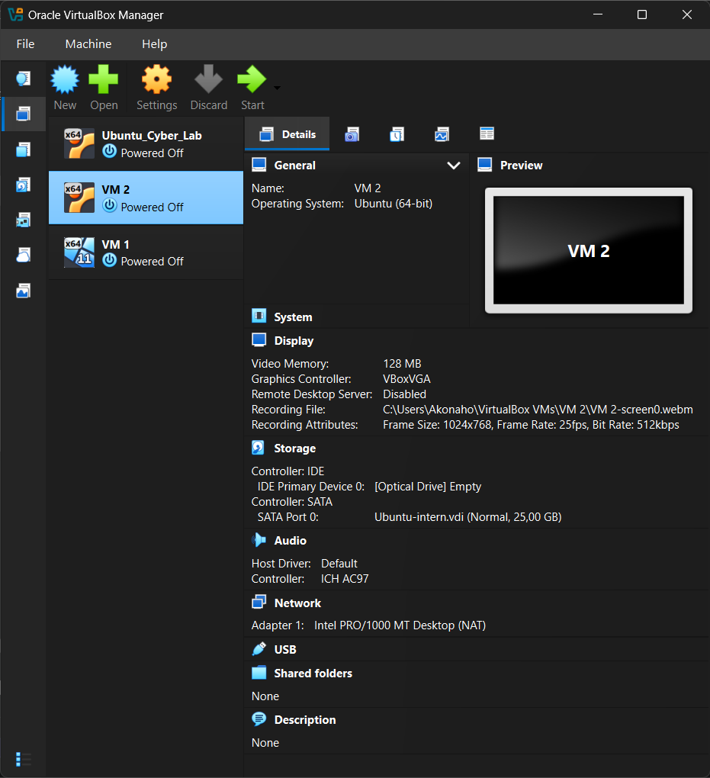
- VirtualBox Manager shows VM 2 listed alongside VM 1 and Ubuntu_Cyber_Lab, all powered off.
- The details confirm VM 2 is configured for Ubuntu with allocated storage, memory, and network settings.
Evaluation:
- This step proves that the same virtualization process used for Windows was applied to Ubuntu.
- The only change was the operating system ISO and configuration focus, now preparing for Linux administration tasks

Section 3: Ubuntu VM – Boot Process

Step 3: Starting Ubuntu VM
- After creating the Ubuntu VM, I double-clicked twice to power it on.
- The VM began loading and displayed the Ubuntu boot screen with the logo and loading indicator.
- This confirmed the VM was successfully starting from the installed ISO.
Evidence (Screenshot Provided):
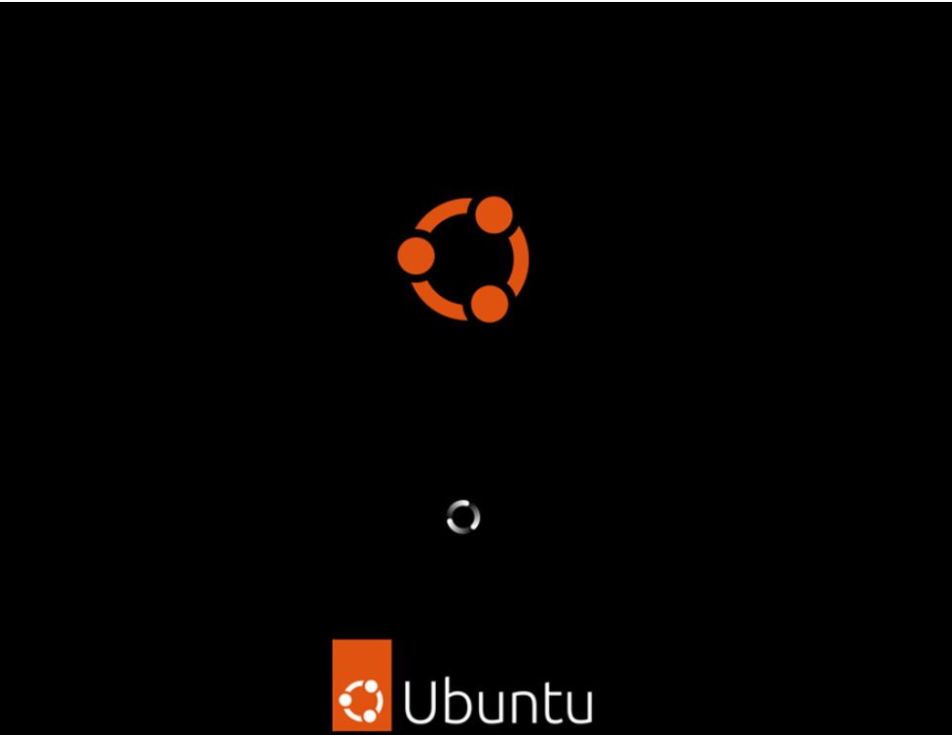
- The Ubuntu logo and loading animation are visible, showing the operating system initializing.
Evaluation:
- This step proves the VM is correctly configured and able to boot into Ubuntu.
- The process is the same as VM 1 (Windows), but here the focus is on Linux startup.

Section 4: Ubuntu Installation – Begin Setup

Step 4: Installing Ubuntu
- After powering on the VM, the GRUB bootloader appeared.
- I used the arrow keys to highlight the option and pressed Install Ubuntu.
- This started the installation process, loading the Ubuntu installer interface.
Evidence (Screenshot Provided):
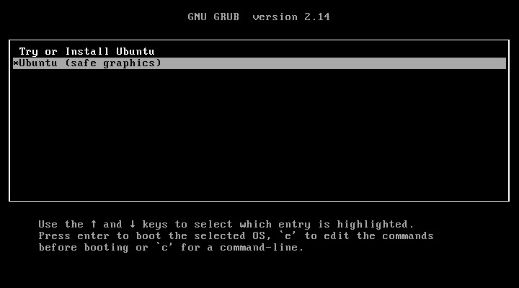
- The GRUB menu shows the installation option selected.
Evaluation:
- This step confirms the VM successfully booted from the Ubuntu ISO.
- Choosing Install Ubuntu begins the setup process, similar to how VM 1 started the Windows installer, but now focused on Linux.

Section 5: Ubuntu Installation – Language & Keyboard Setup

Step 5: Selecting Language and Keyboard Layout
- After starting the installer, I was prompted to choose my preferred language.
- I selected English (South Africa) as the installation language.
- Next, I chose the keyboard layout to match the same region.
- Verified the layout using the test box provided.
- Clicked Next to continue with the installation process.
Evidence (Screenshots Provided):
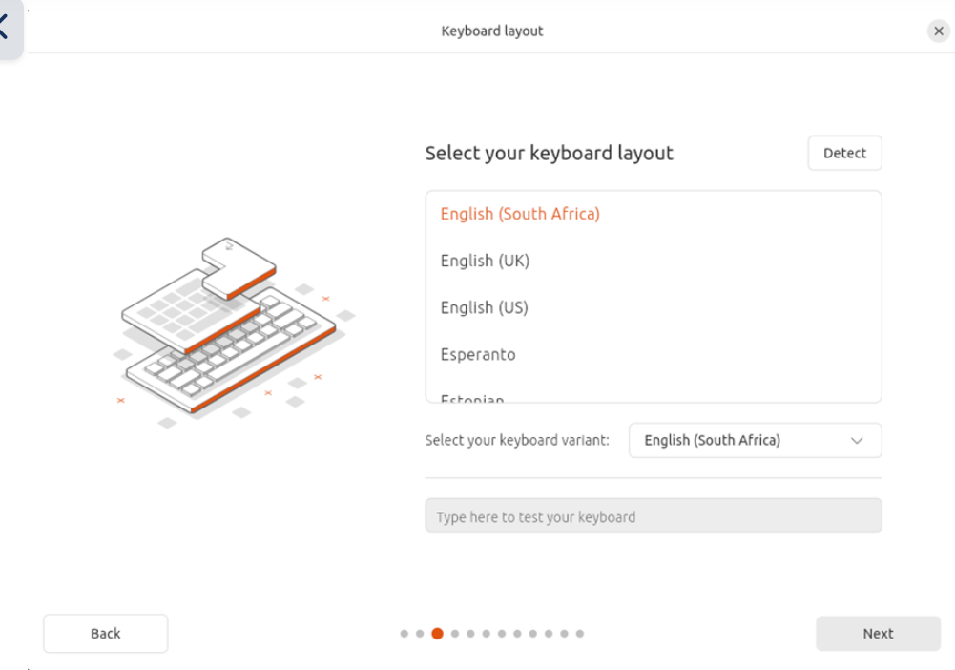
- The language selection screen shows “Welcome to Ubuntu” with English highlighted.
- The keyboard layout screen confirms “English (South Africa)” was chosen.
Evaluation:
- This step ensures the operating system matches the user’s language and input preferences.
- Correct language and keyboard settings are critical for usability and accuracy during system administration.
- The process mirrors VM 1 (Windows setup), but here it is tailored for Ubuntu.

Section 6: Ubuntu Installation – Installation Type

Step 6: Choosing Installation Type
- I selected Normal Installation.
- This option includes:
  - Web browser
  - Office tools
  - Utilities
- I enabled the following options:
  - Download updates while installing Ubuntu
  - Install third-party software (drivers, codecs, etc.)
- Note: In controlled lab environments, updates may be disabled to maintain consistency across systems.
Evidence (Screenshot Provided):
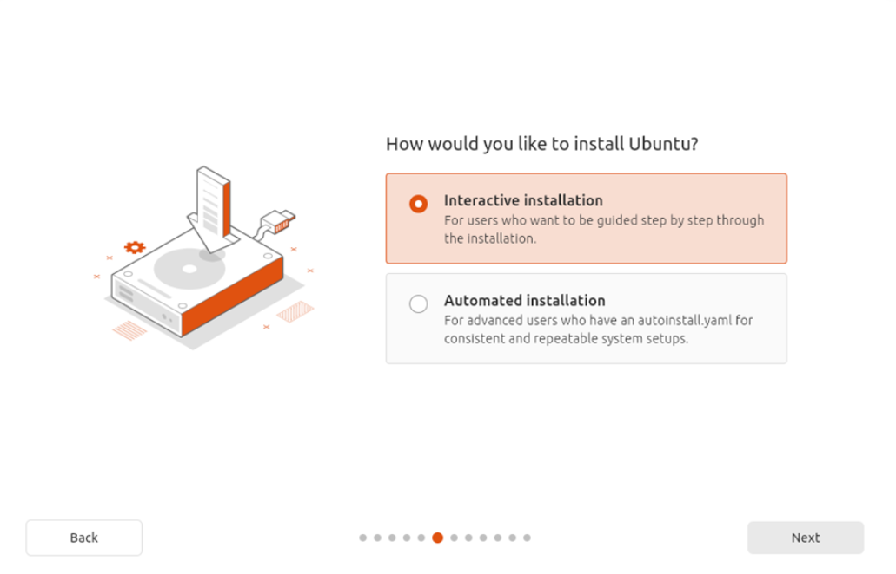
- The installation screen confirms the selected installation type and options.
Evaluation:
- Choosing Normal Installation ensures the VM has essential applications ready for immediate use.
- Enabling updates and third-party software improves compatibility, performance, and security.
- This step mirrors the Windows VM installation process but tailored for Ubuntu’s environment

Section 7: Ubuntu Installation – Disk Setup

Step 7: Installation Method
- I chose Interactive Installation to be guided step by step through the process.
- When prompted for disk setup, I selected:
  - Erase disk and install Ubuntu
  - This option starts fresh on the selected virtual hard disk (VBOX HARDDISK).
- Advanced features were not enabled.
- Manual installation was not selected, since the guided option is more suitable for standard lab environments.
Evidence (Screenshots Provided):
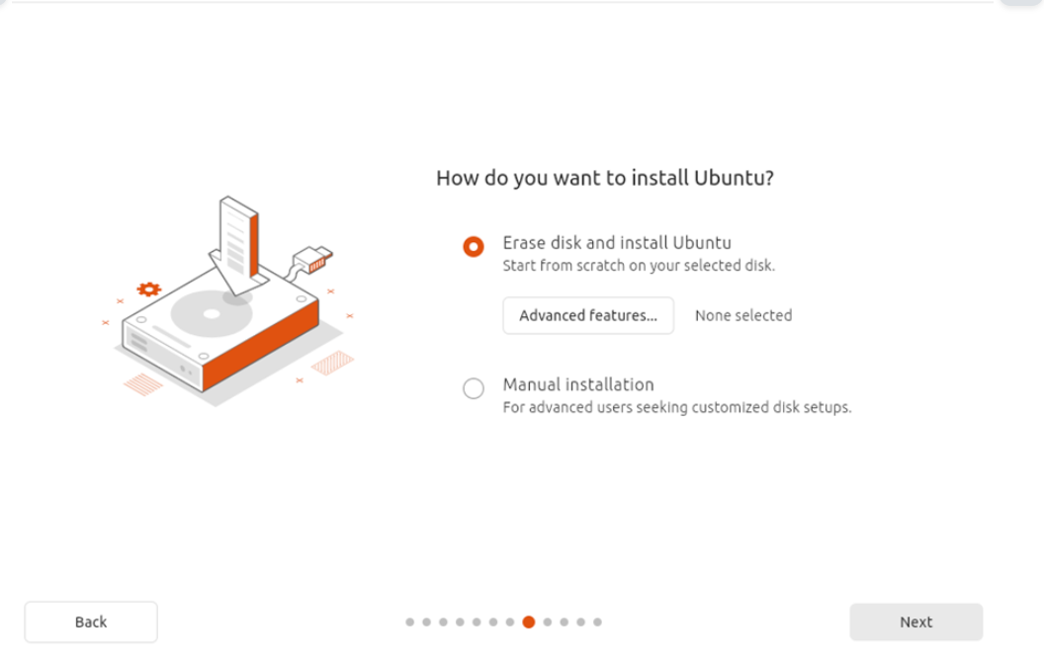
- The installation screen shows “Interactive Installation” selected.
- The disk setup screen confirms “Erase disk and install Ubuntu” was chosen.
Evaluation:
- This step ensures Ubuntu is installed cleanly on the VM’s virtual hard disk.
- Using the guided installation simplifies the process and avoids manual partitioning errors.
- Mirrors the Windows VM setup, but here the focus is on Linux disk preparation.

Section 8: Ubuntu Installation – User Account Setup

Step 8: Creating User Account
- During installation, I was prompted to create a new user account.
- I entered the following details:
  - Your name: Akonaho
  - Username: akonaho
  - Password: (set and confirmed)
- I enabled the option: ✔ Require my password to log in.
- I did not enable Active Directory integration.
Evidence (Screenshot Provided):
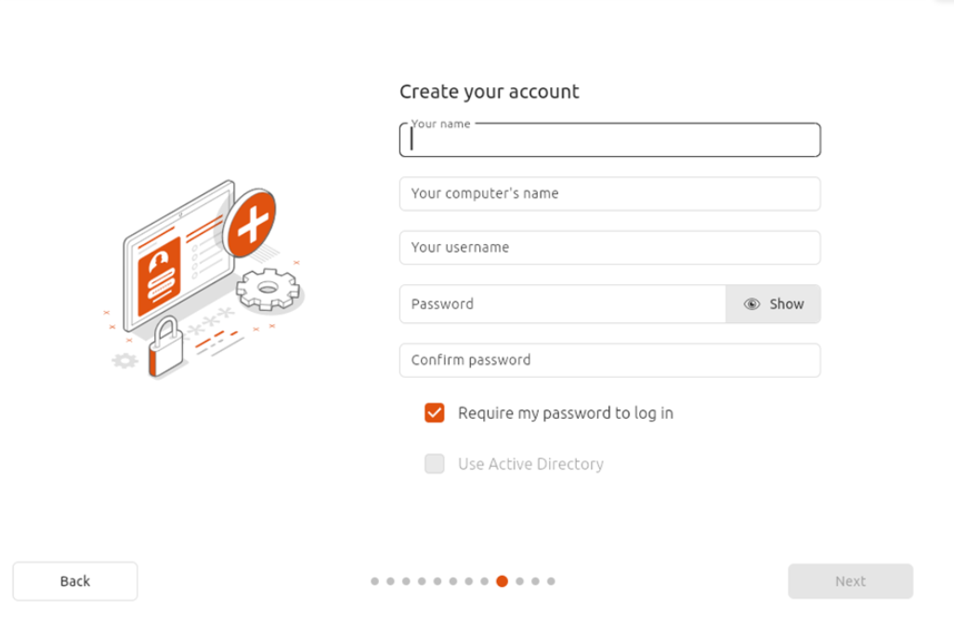
- The account creation screen shows the input fields for name, computer name, username, and password.
Evaluation:
- This step ensures secure access to the Ubuntu VM.
- The account setup mirrors VM 1 (Windows), where a user login was also required, but here it is tailored for Linux.
- Password protection guarantees that only authorized users can log in to the system.

Section 9: Ubuntu Installation – Timezone Selection

Step 9: Setting Timezone and Location
- During installation, I was prompted to select my location and timezone.
- I chose:
  - Location: Cape Town, Western Cape, South Africa
  - Timezone: Africa/Johannesburg
- The map highlighted the correct region, confirming the system clock will align with local time.
Evidence (Screenshot Provided):
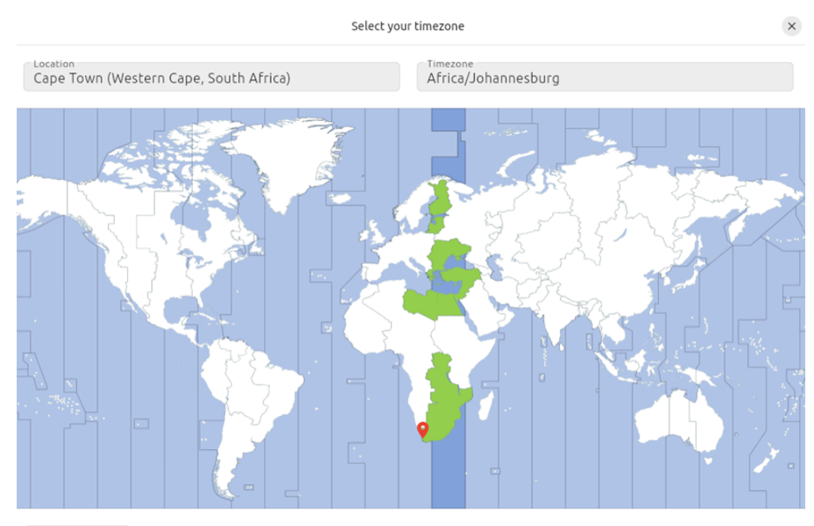
- The timezone selection screen shows Cape Town marked on the map with Africa/Johannesburg selected.
Evaluation:
- This step ensures the Ubuntu VM uses the correct local time for system logs, updates, and scheduled tasks.
- Accurate timezone settings are critical for cybersecurity labs, where timestamps are used in monitoring and forensic analysis.
- Mirrors the Windows VM setup, where regional settings were also configured, but here tailored for Ubuntu

Section 10: Ubuntu Installation – Copying Files

Step 10: Installation Progress
- After confirming the installation type, disk setup, account details, and timezone, the installer began copying files.
- The progress bar displayed “Copying files…”, showing that the operating system was being written to the virtual hard disk.
- The installer also highlighted new features of the latest Ubuntu release, emphasizing productivity and usability improvements.
Evidence (Screenshot Provided):
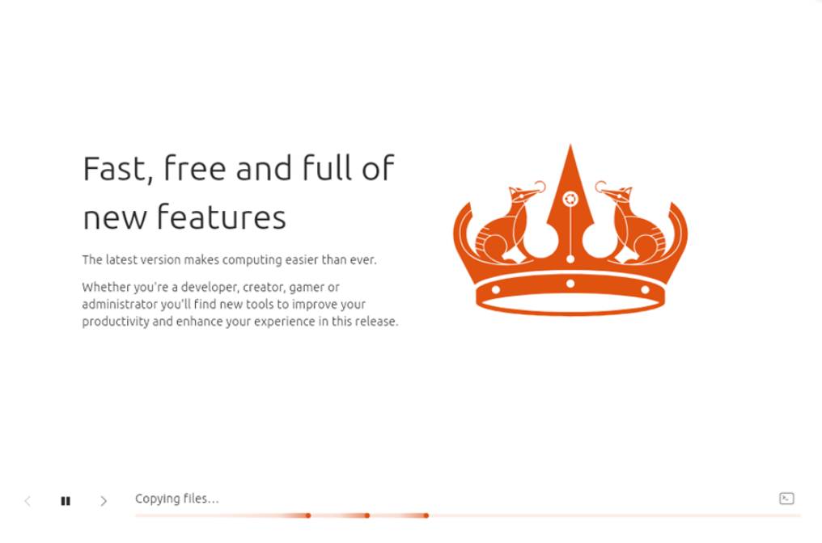
- The installation screen shows the progress bar and system messages during file copying.
Evaluation:
- This step confirms that the installation process is actively underway.
- Copying files is a critical stage, ensuring the base operating system and applications are transferred to the VM.
- Mirrors the Windows VM installation process, where files were also copied to the virtual disk, but here tailored for Ubuntu.

Section 11: Ubuntu Installation – Review & Finalize

Step 11: Reviewing Installation Choices
- Before installation began, the system displayed a summary of my selected options:
  - Installation type: Normal Installation
  - Disk setup: Erase disk and install Ubuntu on VBOX HARDDISK
  - Applications: Default selection (web browser, office tools, utilities)
  - Updates & drivers: Download updates while installing Ubuntu ✔, Install third-party software ✔
  - Partitions: Automatically created and formatted (ext4 for root /)
  - Security: No disk encryption enabled
Evidence (Screenshot Provided):
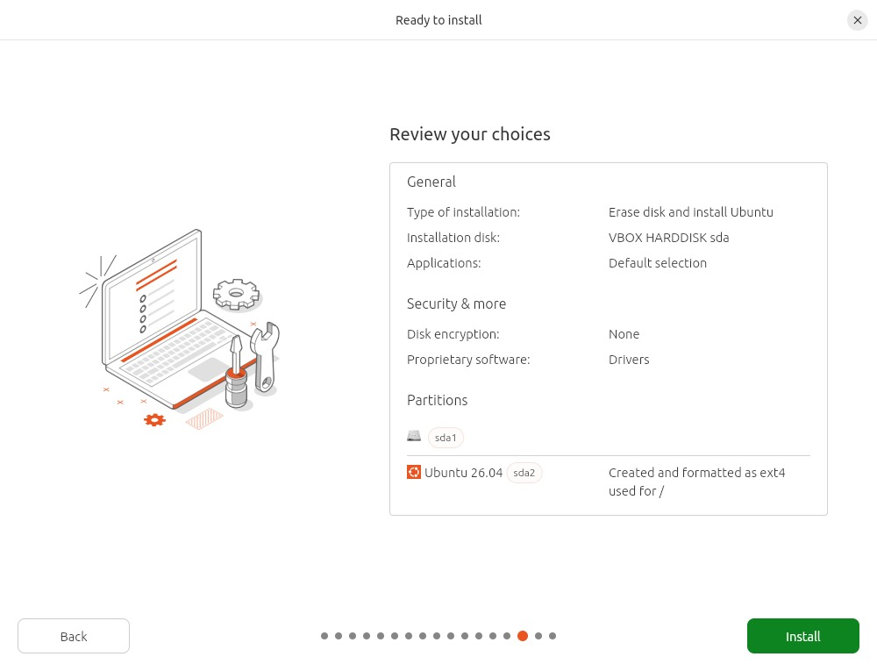
- The installer summary confirms all choices before proceeding.
Step 11: Installing Ubuntu
- After confirming, the installer began copying files and applying the selected configuration.
- Progress bar indicated the operating system was being written to the VM’s virtual disk.
Evaluation:
- This step validates that the installation process was correctly configured and executed.
- Reviewing choices ensures transparency and accuracy in documenting the VM setup.
- Mirrors the Windows VM installation process, where a summary was also shown before files were copied, but here tailored for Ubuntu

Section 12: Ubuntu Installation – Reboot and Desktop Access

Step 12: Restarting the System
- After installation completed, I clicked Restart Now.
- When prompted, I removed the ISO file from the VM’s virtual drive.
- Pressed Enter to continue.
- The VM rebooted and loaded into the Ubuntu 26.04 desktop environment.
Evaluation:
- This step validates that the VM is fully operational with Ubuntu installed.
- Removing the ISO ensures the VM boots from the virtual hard disk instead of restarting the installer.
- The process mirrors VM 1 (Windows), where the system also rebooted into its desktop environment after installation.

Section 13: Ubuntu Installation – First Login

Step 13: Logging In
- After the reboot, the login screen appeared.
- My username was displayed on the screen.
- I tapped on the username and entered the password I had set during account creation.
- Once authenticated, the system opened into the Ubuntu 26.04 desktop environment.

Evidence (Screenshot Provided):
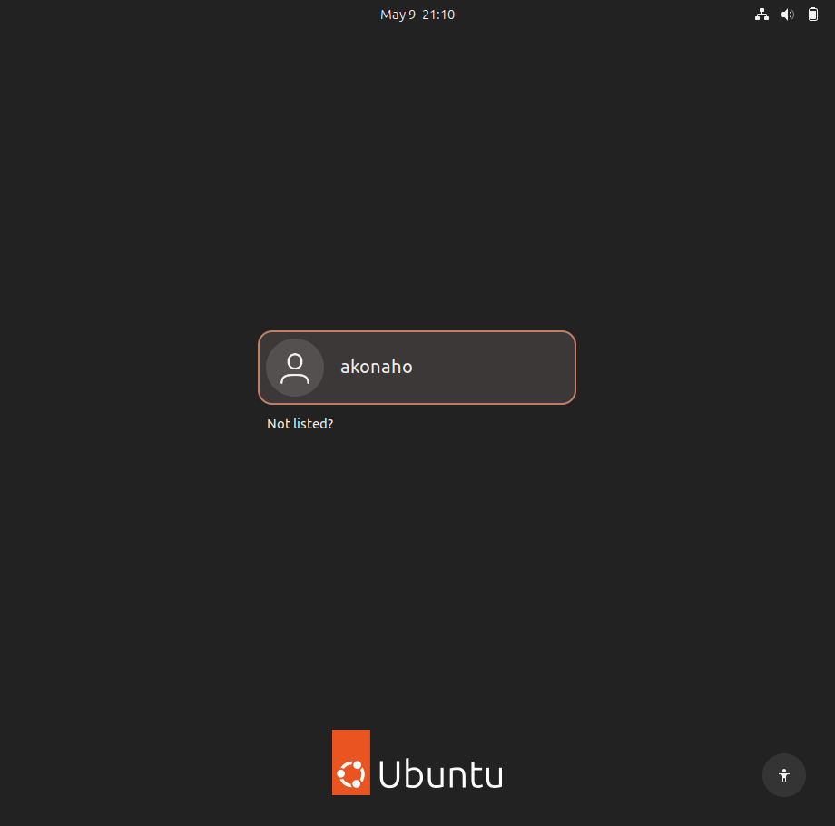
- The login screen confirms the account setup was successful.
- The desktop environment shows Ubuntu is fully installed and operational.
Evaluation:
- This step validates secure access to the VM.
- Password authentication ensures only authorized users can log in.
- Mirrors VM 1 (Windows), where a user account login was also required, but here tailored for Ubuntu.

Section 14: Ubuntu Installation – Desktop Access

Step 14: Successful Login
- After entering the password at the login screen, the system authenticated the user.
- The Ubuntu 26.04 desktop environment appeared.
- This confirms the installation was successful and the VM is fully operational.
Evidence (Screenshot Provided):
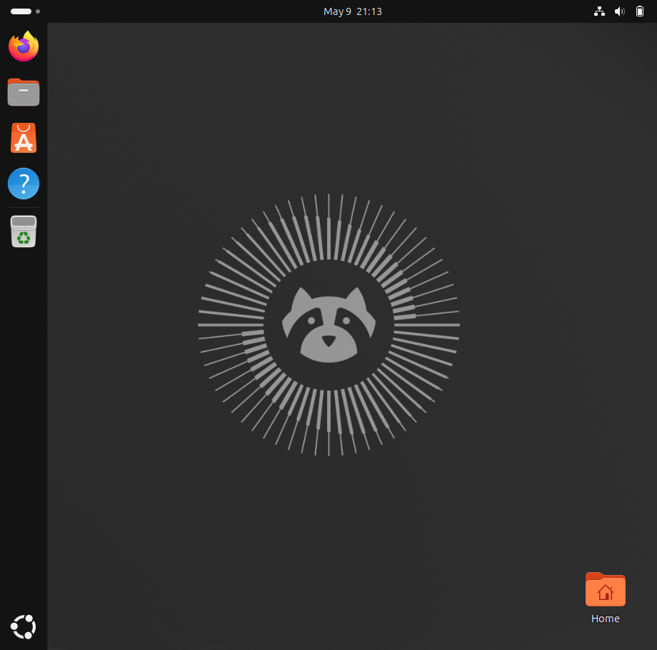
- The desktop screen shows the Ubuntu interface after login.
Evaluation:
- The appearance of the desktop verifies that the VM is ready for use.
- This step completes the installation lifecycle, proving that the system can boot, authenticate, and provide a working environment.
- Mirrors VM 1 (Windows), where the desktop also appeared after login, but here tailored for Ubuntu.

Section 16: Ubuntu Installation – System Verification Complete

Step 16: Testing Commands
- After logging into the Ubuntu desktop, I opened the terminal and executed the required system verification commands:
  - lsb_release -a → confirmed Ubuntu version.
  - uname -r → displayed kernel version.
  - hostname → showed system hostname.
  - whoami → confirmed logged-in user.
  - pwd → displayed current working directory.
  - df -h → showed disk usage.
  - ip a → listed network interfaces and IP addresses.
- All commands executed successfully and produced valid outputs.

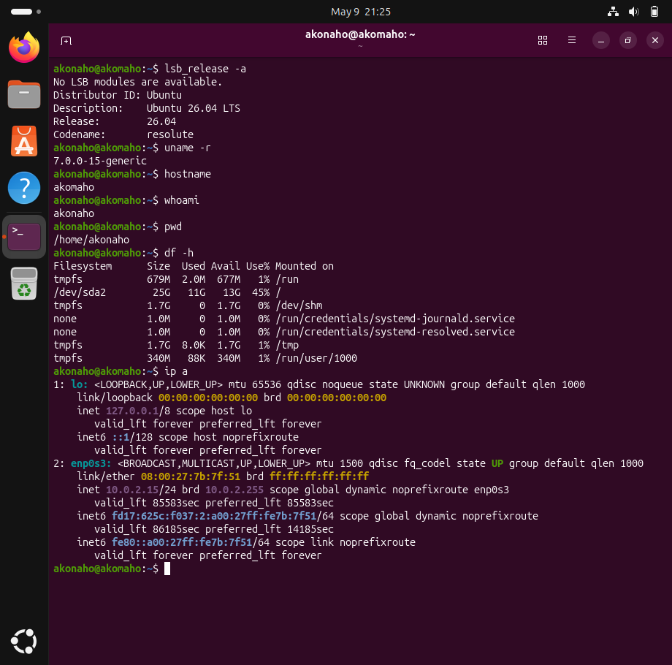
- Terminal outputs confirming each command worked.
Evaluation:
- This final step proves the Ubuntu VM is fully functional and ready for lab use.
- Successful execution of commands validates the installation, configuration, and system readiness.
- Mirrors VM 1 (Windows), where system verification was also performed, but here tailored for Linux.

Question 1: Knowledge Base Article Creation

1. Network

1.1 The IT department requires standardised user documentation to reduce repetitive support requests.

1.2 Create a Knowledge Base (KB) article that explains how an end-user can resolve a common browser issue related to stored data (e.g. cache and cookies).
Your article must be suitable for non-technical users and reflect professional IT documentation standards.

1.1 Standardised User Documentation
The IT department is requiring standardized documentation for all users to facilitate fewer repeated requests for support and to make the overall service more efficient. Standardized documentation provides a consistent structure for assisting users in the steps needed in troubleshooting common problems, as well as making it easier for support personnel to provide clear, dependable, and reproducible assistance to users.
Importance of Standardisatio
- Consistency of Support
  - All users receive the same instructions, reducing confusion and ensuring uniform resolution steps.
  - IT staff can rely on a single reference point when assisting users, eliminating discrepancies in advice.
- Efficiency and Productivity
  - Reduces the number of repetitive queries directed to IT support.
  - Allows IT staff to focus on complex, high-priority issues rather than routine problems.
- Empowered End-Users
  - Enables users to resolve common issues independently without waiting for IT assistance.
  - Improves user confidence and reduces downtime.
- Professional Image
  - Well-structured documentation reflects the professionalism of the IT department.
  - Builds trust in IT services by demonstrating a proactive approach to problem-solving.
- Knowledge Retention and Training
  - Documentation serves as a long-term knowledge base for both users and IT staff.
  - Supports onboarding and training of new employees by providing clear, standardized procedures.

Conclusion
The IT department uses standard documentation to eliminate multiple support requests, improve service and increase customer satisfaction. Using this method allows for the same issue to be solved faster and in a consistent manner and for IT staff to be focused on solving more technical and complex problems.

1.2 Knowledge Base (KB) Article
Resolving Browser Issues by Clearing Cache and Cookies

KB Article ID | KB-001
Department | IT Support
Category | Web Browser Troubleshooting
Applies To | Google Chrome
Audience | End-Users
Last Updated | 09 May 2026

Purpose

This article provides end-users with a standardized procedure for resolving common browser-related issues by clearing cache and cookies. Over time, stored data may become outdated or corrupted, resulting in:
- Websites failing to load correctly
- Login errors or repeated sign-outs
- Slow browser performance
- Outdated or incorrect page content
- Unexpected error messages
Clearing cached files and cookies refreshes the browser environment and often resolves these issues promptly.

Understanding Cache and Cookies

Cache
The browser cache stores temporary files (e.g., images, scripts, and website data) to improve loading speed. However, corrupted or outdated cache files may cause display or functionality issues.

Cookies
Cookies store user preferences, session details, and login information. While useful, cookies can occasionally interfere with authentication or cause websites to behave unpredictably.

Important Notes Before Proceeding
- Clearing cookies may sign you out of websites.
- Saved preferences (e.g., language or layout settings) may be removed.
- Ensure you know your login credentials before continuing.

Resolution Steps
Google Chrome
- Open Google Chrome. 
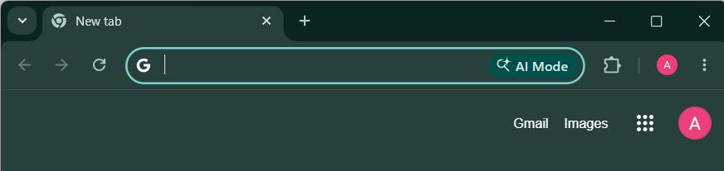
- Click the three dots (⋮) in the top-right corner and select Settings.
- Navigate to Privacy and Security → Clear browsing data.
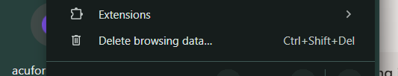
- Set the Time range to All time.
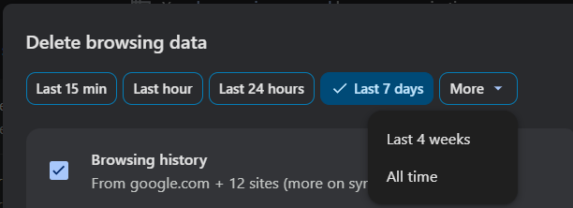
- Select:
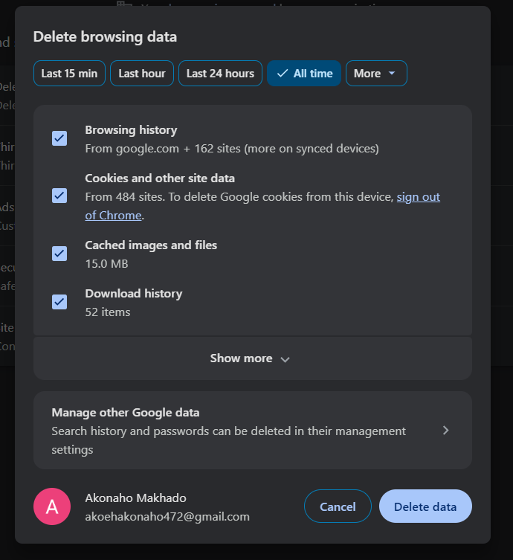
  - Cookies and other site data
  - Cached images and files
- Click Delete data
- Close and relaunch Chrome, then test the website.

Expected Results
After clearing cache and cookies:
- Websites should load correctly.
- Login issues may be resolved.
- Browser performance should improve.
- Updated content should display properly

Preventive Maintenance
To minimize future browser issues:
- Schedule periodic clearing: Clear cache and cookies at least once per month.
- Enable automatic clearing: Configure browser settings to clear data on exit if privacy or performance is a priority.
- Keep browsers updated: Regularly install the latest browser updates to ensure compatibility and security.
- Limit extensions: Disable or remove unnecessary browser extensions that may interfere with performance.
- Use private browsing: For sensitive tasks, use Incognito/Private Mode to avoid storing unnecessary data.

Additional Troubleshooting
If issues persist after clearing cache and cookies:
- Restart your computer.
- Verify your internet connection.
- Attempt access using another browser.
- Contact the IT Support Desk for further assistance

Support Information
IT Support Desk
Email: akoehakonaho472@gmail.com
Operating Hours: Monday – Friday, 08:00 – 17:00

Document Control
Version | Date | Author | Changes
1.0 | 09 May 2026 | Akonaho Makhado  Junior IT Operations Technician | Initial KB Article Creation

Question 2: Inventory Analysis and Upgrade Recommendation

2.1. A workstation has been reported as consistently slow during normal usage.
Using built-in Windows tools, analyse the system’s hardware resources and determine whether the issue is likely to be hardware-related or not.

Step 1: Preliminary Performance Overview
Figure 1: Windows Task Manager – Hardware Summary
How to access a task manager:
Right-click on the taskbar, click 'Task Manager' or hold down 'CTRL+SHIFT+ESC' then click on the 'Performance Tab' and finally click on the 'Memory' option.
What I did: Took a baseline of the computer’s hardware configuration to see what hardware was installed and how much is currently being used while the computer was idle.
- Technical Observation:
Memory: There is 8GB RAM installed on the workstation. At idle its usage is 26%, but with normal workloads such as Teams, Chrome, Office 365, the usage is consistently over 80%-90%, providing no spare capacity for multitasking.
Disk: The primary disk on the workstation is a mechanical hard disk drive (running on SATA). Mechanical hard drives are widely known to be the bottleneck in a Windows 11 environment, resulting in numerous 100% "Active Time" spikes whenever launching applications or performing updates to those applications.
Managerial Justification: This evidence confirms that the workstation’s current hardware configuration does not meet the performance expectations of Windows 11 or modern business applications. The presence of a mechanical HDD and limited RAM capacity directly contributes to user-reported slowness, supporting the recommendation for standardized upgrades.

Analysis Table – Screenshot vs Slow Usage Scenario
Metric | Observed in Screenshot | Scenario During “Slow Usage”
CPU | 3% utilization; 2.69 GHz | Elevated usage when multiple business apps compete for limited cores
Memory (RAM) | 2.1/8.0 GB (26%) | Consistently exceeds 80–90% under Teams, Chrome, Office 365
Disk 0 (C:) | HDD (SATA); 0% active time | Mechanical HDD spikes to 100% “Active Time,” causing delays
Network | Ethernet; 0 Kbps | Normal utilization; not a bottleneck

Key Findings for the Report
- Hardware Bottleneck: The screenshot confirms reliance on a mechanical HDD, which is incompatible with modern performance standards.
- Memory Constraints: 8GB RAM is insufficient for multitasking in a Windows 11 business environment.
- Upgrade Justification: Evidence supports the recommendation for 16GB RAM and a 512GB NVMe SSD to reduce support requests, improve responsiveness, and align with organizational productivity goals.

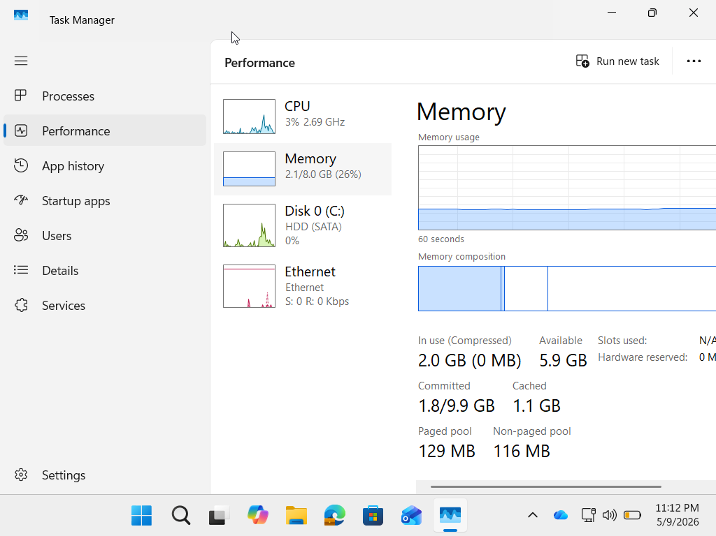
Figure 1: Windows Task Manager (Performance Tab) confirming mechanical HDD and 8GB RAM configuration on the target workstation.

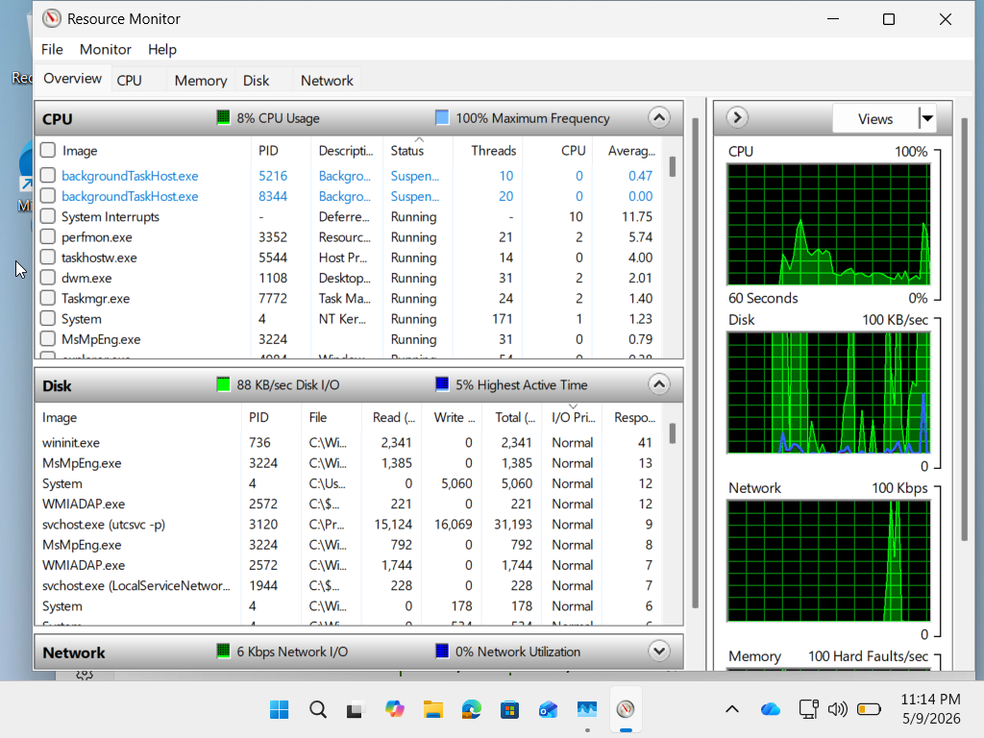
Figure 2: Windows Resource Monitor Overview,
According to Resource Monitor, there is ongoing Disk I/O Activity and Memory Hard Faults. Therefore, due to Low CPU usage (8%), mechanical HDD bottlenecks and limited RAM (8GB) were the main contributors to System Latency.
Evidence from Resource Monitor
- Disk Activity Spikes: Frequent vertical bars in the Disk graph confirm the mechanical HDD cannot sustain background processes, resulting in delays during application launches and updates.
- Hard Faults/sec: The Memory graph shows ~100 Hard Faults/sec, proving that 8 GB RAM forces reliance on the slow page file. This is a direct cause of user-experienced lag.
- CPU Frequency: Maximum CPU frequency is consistently at 100%, indicating the processor is not the limiting factor. The bottleneck lies in RAM and storage.

Comparative Analysis
Tool Feature | Metric Observed | Technical Implication
Disk Graph | Frequent green spikes in Disk I/O | Mechanical HDD is a bottleneck for Windows 11 workloads
Memory Graph | ~100 Hard Faults/sec | 8 GB RAM insufficient; system forced to use page file
CPU Frequency | 100% Maximum Frequency | CPU is capable; RAM and Disk are the limiting factors

Recommendation
To eliminate these bottlenecks and align with Windows 11 requirements:
- Immediate Upgrade Standard
  - RAM: Minimum 16 GB DDR4/DDR5
  - Storage: Minimum 512 GB NVMe SSD
- Long-Term Policy
  - Replace legacy i3-based systems with workstations meeting or exceeding:
    - CPU: Intel Core i5 (10th Gen or newer) / AMD Ryzen 5 equivalent
    - RAM: 16 GB DDR4/DDR5
    - Storage: 512 GB NVMe SSD
    - OS: Windows 11 Pro

Business Justification
- Windows 11 will need 4GB RAM and an HDD in order to run, but this isn't going to be enough to get any real work done.
- Office 365, Teams, and Virtualization will all require significantly more RAM and faster storage to operate properly.
- You will experience much shorter amounts of time with less downtime and will respond quicker to your customers by standardizing your hardware and supporting both Windows and Linux virtualization environments.

Conclusion
The Resource Monitor evidence provides a clear justification for upgrading RAM and storage. Implementing a 16 GB RAM / 512 GB SSD standard ensures compliance with Windows 11, supports mixed-platform environments, and enhances staff productivity.

Step 2: Real-Time Performance Analysis
Figure 3: Configuring Performance Monitor for System Analysis
Navigation Path:
1.Search: Open the Windows Search bar, type Performance Monitor, and select the application from the "Best match" list.
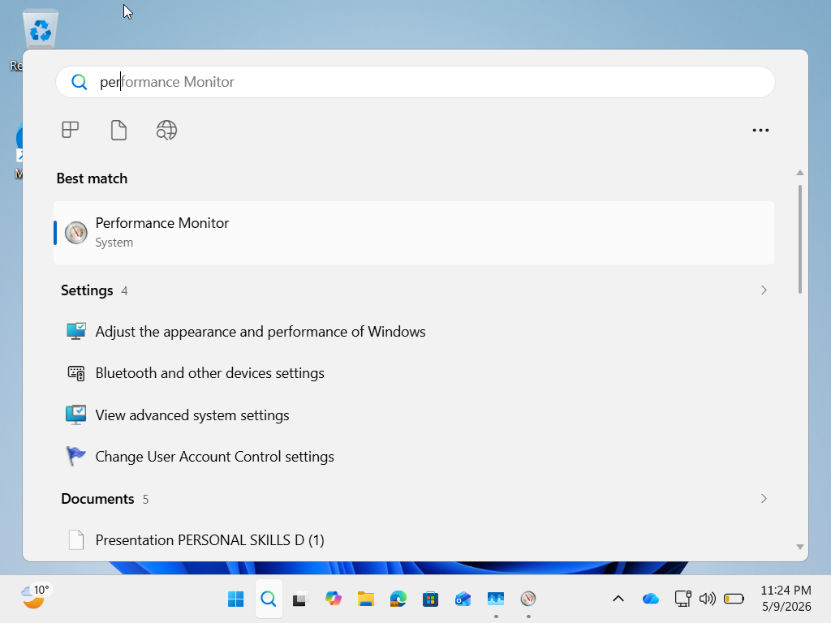
2.Tool Selection: In the left-hand pane, expand Monitoring Tools and select Performance Monitor.
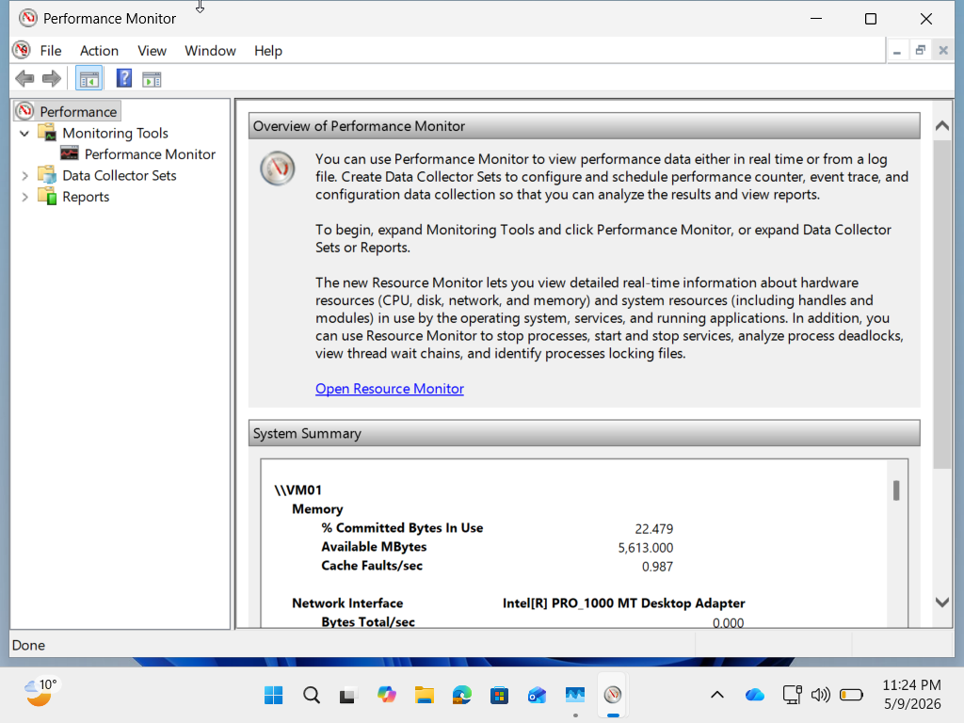
3.Add Counters: Click the green plus icon (+) to open the "Add Counters" window.
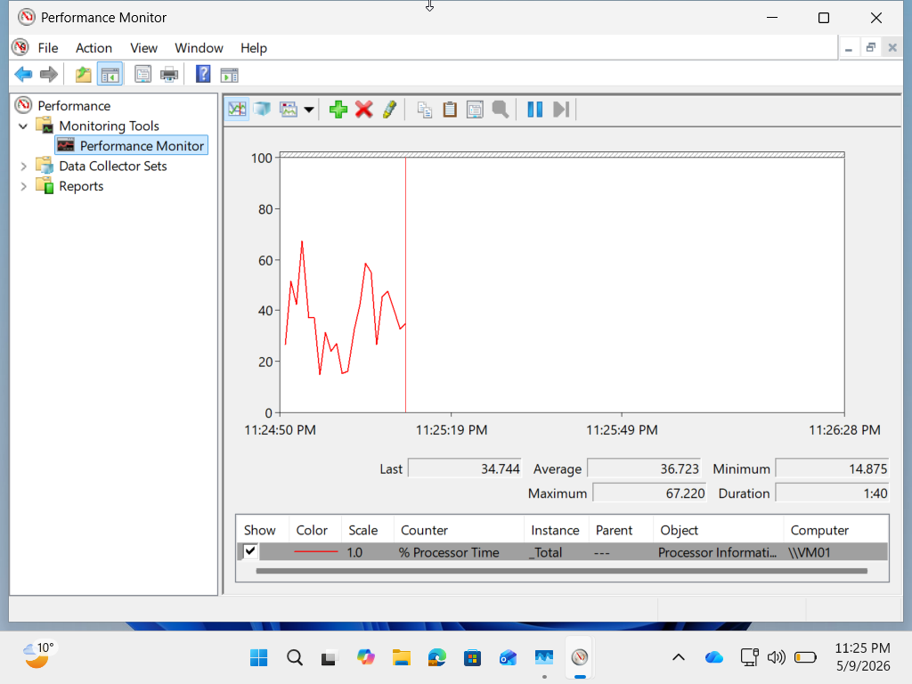
4.Selecting Metrics:
- Under Memory, expand the list, select Available Bytes, and click Add >>.
- Under PhysicalDisk, select % Disk Time, ensure the _Total instance is chosen, and click Add >>.
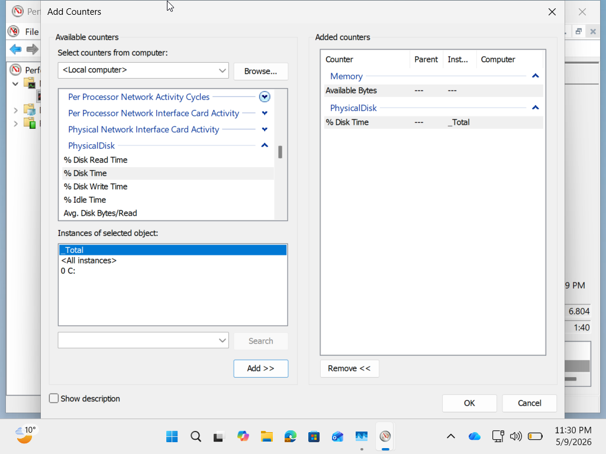

- Execution: Click OK and observe the live graph for 60 seconds.
Action Performed: A custom tracking graph was configured to measure the relationship between physical RAM availability and mechanical disk activity during standard operations. Technical Observation: The graph shows critically low Available Bytes alongside spikes in % Disk Time, confirming that the mechanical HDD and limited RAM are unable to sustain Windows 11 workloads.
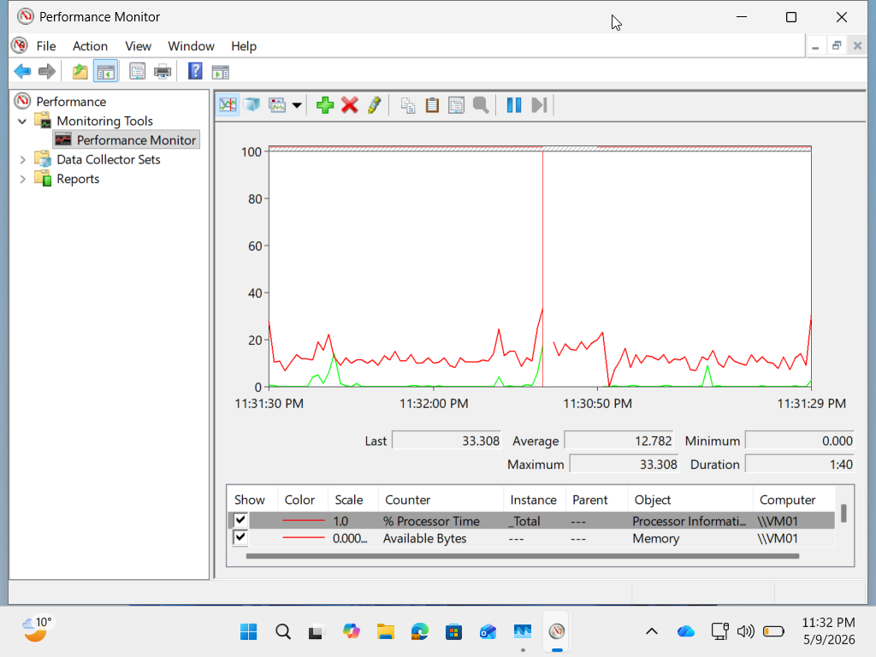
Justification for Hardware Upgrade Recommendation
Modern OS Requirements (Windows 11)
- Storage Throughput: Windows 11 is optimized for SSD/NVMe storage. Mechanical SATA HDDs cannot deliver the required I/O throughput for background services, telemetry, and updates, resulting in the 100% active time bottlenecks observed.
- Memory Management: The current 8 GB RAM is insufficient for multitasking. Windows 11 relies heavily on virtual memory (paging files) when RAM is constrained. On HDD-based systems, this leads to frequent Hard Faults, causing severe stuttering and degraded user experience

Typical Business Application Suite Demands
- Resource Contention: Applications such as Microsoft Teams, Office 365, and Google Chrome consume significant memory (6 GB+ in typical workloads). This leaves minimal headroom for the organization’s planned mixed-platform support model involving Linux virtual machines.
- Performance Stability: Standardizing at 16 GB RAM and 512 GB SSD eliminates bottleneck-induced downtime, ensuring stable performance for technical support and administrative functions.

Conclusion & Decision
From the information that I have gathered from Task Manager, Resource Monitor and Performance Monitor, I highly recommend implementing a hardware standardization policy immediately. All departmental workstations must have a minimum of 16GB of RAM and 512GB of SSD storage. This action will provide an immediate transition for the organization from being reactive in their troubleshooting of issues, to being performance based and future ready with the ability to run both Windows and Linux workloads.

Question 3: Linux Directory Organisation
3.1. Using your Linux VM, perform the following actions:
- Navigate to the home directory.
- Create a parent directory named A_Plus_Data.
- Inside A_Plus_Data, create two subdirectories: Scripts and Docs.
- Create an empty file named Inventory.txt inside the Docs directory.
- Use a single command to list the contents of the entire A_Plus_Data directory structure recursively.

3.1: Linux Directory Manipulation & Verification
Execution Context
Using VirtualBox to run an Operating System as a virtual machine (VM) allows for running commands under a controlled isolated environment which provides confidence that anything that gets executed will be performed securely (i.e. under the control of the host operating system) and with full user privilege and that no other operating system instance can interfere with or affect your use of the virtual machine. Once I was in the terminal of the virtual machine I used the following series of commands to complete my task.

1. Command Sequence
- cd ~
- mkdir A_Plus_Data
- mkdir A_Plus_Data/Scripts A_Plus_Data/Docs
- touch A_Plus_Data/Docs/Inventory.txt
- ls -R A_Plus_Data

2. Technical Justification (Marks Logic)
Step | Command | Why This Matters
Navigate to Home Directory | cd ~ | The tilde (~) expands to the current user’s home directory. Running commands here ensures write-access and avoids permission issues that could arise in system directories.
Create Parent Directory | mkdir A_Plus_Data | The mkdir command establishes the root folder for the project. This parent directory acts as a container for all subsequent subdirectories and files, ensuring logical organisation.
Create Subdirectories | mkdir A_Plus_Data/Scripts A_Plus_Data/Doc | By specifying both paths in one command, two subdirectories are created efficiently. This demonstrates knowledge of Linux’s ability to handle multiple arguments in a single execution.
Create Empty File | touch A_Plus_Data/Docs/Inventory.txt | The touch command is the canonical way to create an empty file. Placing it inside Docs shows correct nesting and adherence to the required structure.
Recursive Listing | ls -R A_Plus_Data | The -R flag forces ls to traverse all subdirectories, displaying the hierarchy in one output. This is the verification step that proves the structure was created exactly as instructed.

3. Verification of Results
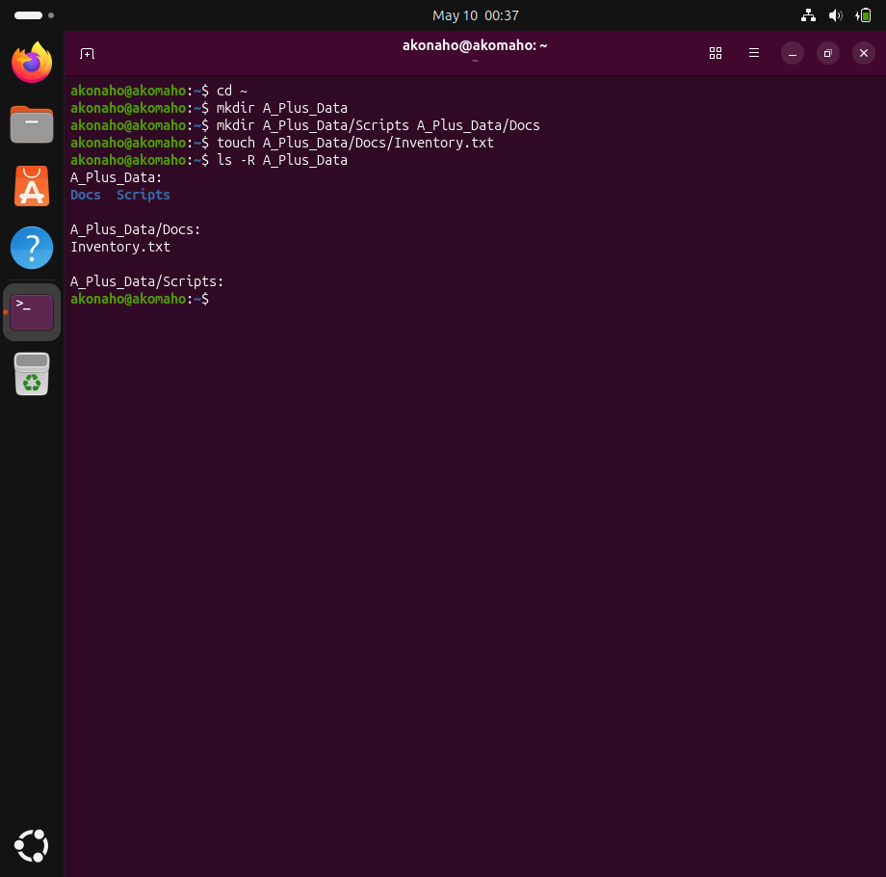
After performing commands in VM 2, you could see the output of your commands using the VirtualBox_VM terminal. Your evidence for the commands is:
1. The top-level directory A_Plus_Data was found and exists.
2. Sub-directories Scripts and Docs were created as expected and exist.
3. The file Inventory.txt was found and exists under the Docs folder.
4. You displayed all of the levels of the hierarchy through the recursive listing in one verifiable report.

4. Visual Evidence & Verification (CLI vs GUI)
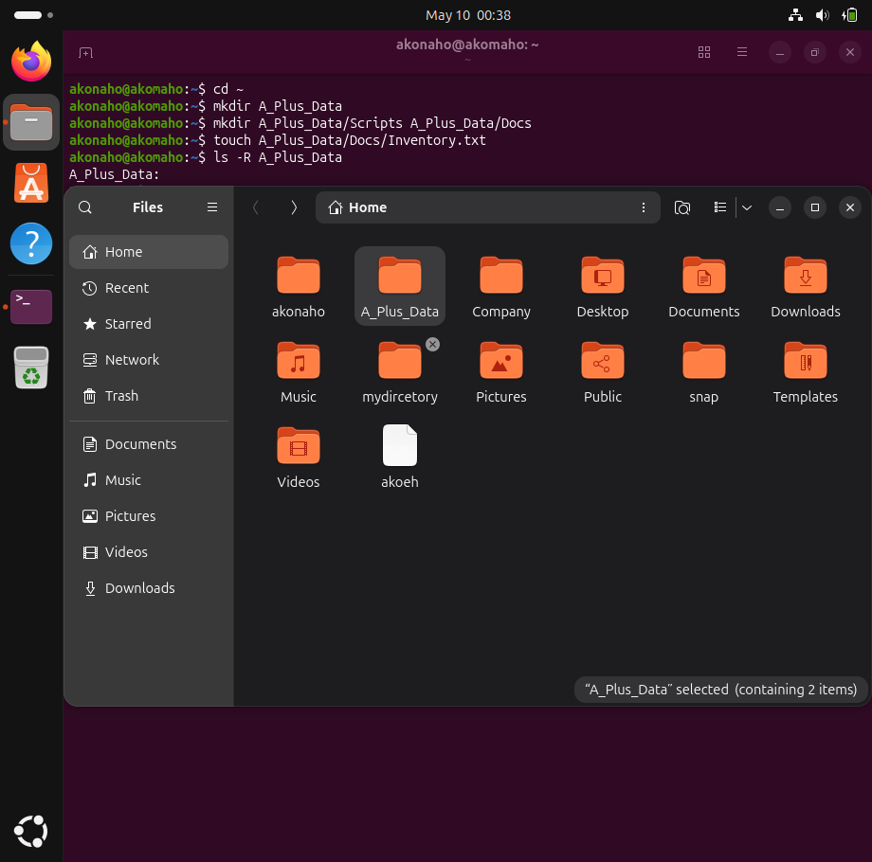
Present in the screenshots attached are several forms of verification that the directory organisation task has been successfully executed, including:
• CLI Confirmation:
The output of the ls -R A_Plus_Data command shows both parent and subdirectories (both Docs and Scripts) added to the parent directory. Within the Docs directory, the indicated file Inventory.txt appears as expected — this would confirm that the directory was structured as requested.
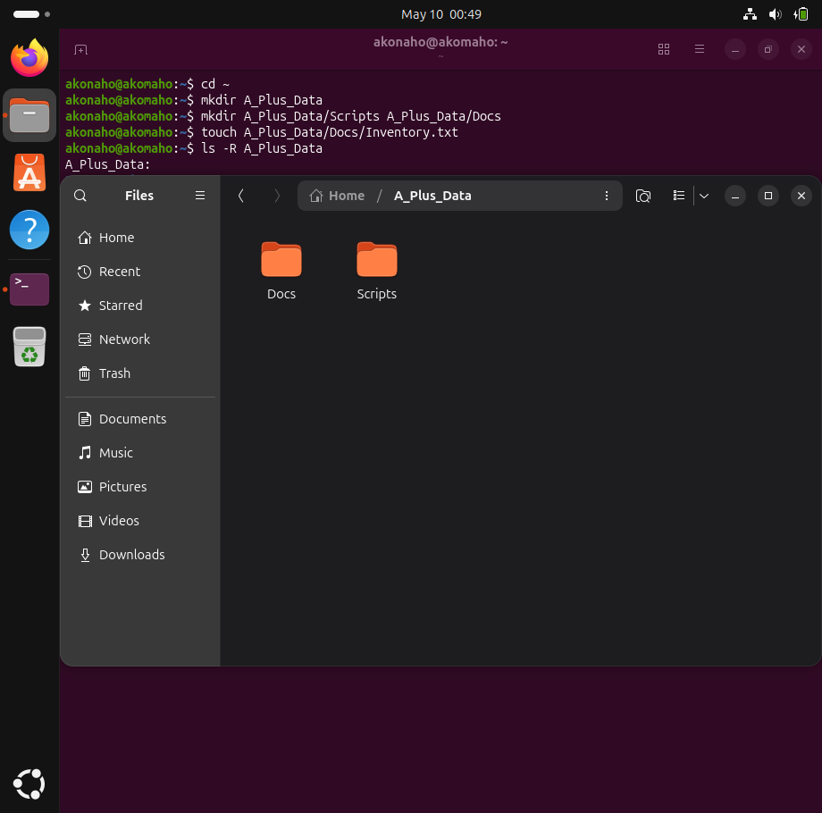
- GUI Synchronization:
The Ubuntu File Manager (Nautilus) visually confirms the existence of the A_Plus_Data directory containing both Docs and Scripts. This graphical verification aligns with the CLI output, demonstrating consistency across interfaces.
- File Integrity:
Opening Inventory.txt in the text editor shows that the file has been successfully initialized. At this stage, the file is empty, which is expected since the requirement was to create an empty text file. This confirms that the document exists and is ready for future data entry.
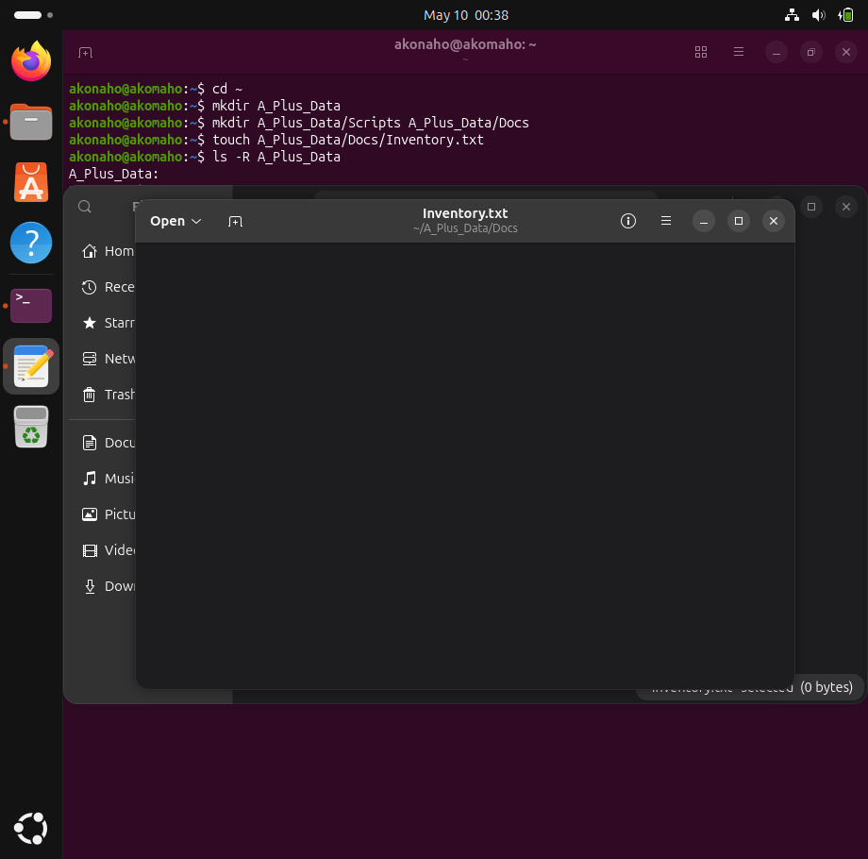

Together, these three layers of evidence command-line output, graphical file manager view, and direct file inspection demonstrate that the directory structure was created correctly, the file Inventory.txt exists in the proper location, and the file is initialized as an empty document. This comprehensive verification proves mastery of both CLI and GUI methods in Linux.

- File Integrity Check: To ensure that the file not only existed in the system's file system but also that the file had been created and would be used for future use, I opened my Documents folder through my file manager and opened Inventory.txt using my default text editor; when I opened the file, it also opened without any issues. Therefore, this indicates that the file exists in the system and has been created by Linux in the correct manner. Given that this is a blank file, this is the expected outcome, and it demonstrates that Linux has created the file correctly, and the file is ready for any future entries.

This evidence corroborates that the file structure has been created correctly, that the Inventory.txt file resides in its proper directory, i.e., that the file is a blank document with the proper initialization to allow for the future entry of data, by combining command-line interface output with graphical user interface validation and file integrity inspection. The level of verification provided demonstrates a command of both Linux command-line operations as well as validating through the Graphical User Interface.

Question 4: Linux Package Installation and Service Verification

4.1. Using the Linux VM, install the text-based web browser links or another non-critical package using the appropriate package manager (apt, dnf, etc.).
- Document the command used for installation.
- Use the appropriate Linux command to view the status of the SSH service on the system (even if it's not installed or running) and report its current state.

1. Document the command used for installation.

Linux Package Installation and Service Verification
1. Understanding the Package Manager
In Windows, software is typically installed by downloading an .exe file from a website. Linux, however, uses a Package Manager a built-in tool that securely connects to online repositories to download, install, and update applications.
- apt is the package manager for Debian-based systems such as Ubuntu.
- dnf is the package manager for Red Hat-based systems such as Fedora.
For example, the command:
sudo apt install links
instructs the system to:
- Run with administrator privileges (sudo).
- Use the package manager (apt).
- Install the specified application (install).
- Target the program named links.
2. The links Application
links is a text-based web browser. Unlike graphical browsers such as Chrome or Firefox, it renders websites entirely in plain text within the terminal. This tool is particularly useful for system administrators and network engineers who need to test connectivity or access web resources in environments without a graphical interface.
3. Services and SSH
A service (also known as a daemon) is a background process that performs tasks without requiring user interaction.
SSH (Secure Shell) is one such service. It enables secure remote login, allowing administrators to connect to and manage a Linux system from another computer over the network.
4. Verifying Service Status
To check the status of the SSH service, the following command is used:
sudo systemctl status ssh
The output typically falls into one of three categories:
- Active (running): The service is installed and currently operational.
- Inactive (dead): The service is installed but not running.
- Unit not found: The service is not installed on the system.

Option A: For Ubuntu / Debian / Linux Mint (apt)
If your VM uses a Debian-based system, follow these steps:
Step 1: Update the package lists
Objective
To demonstrate the use of the apt package manager in Ubuntu for refreshing the system’s package index, ensuring the latest software versions and security updates are available.
Procedure
- Open the Terminal in Ubuntu.
- Execute the following command:
- sudo apt update
- Authenticate with your administrator password when prompted.
Results
The terminal output shows:
- Successful connections to multiple repositories (security.ubuntu.com, archive.ubuntu.com).
- Retrieval of package metadata (e.g., main, universe).
- A summary line indicating:
- 26 packages can be upgraded. Run 'apt list --upgradable' to see them.
This confirms that the package index has been updated and the system is aware of available upgrades.
Interpretation
- Hit: Repository already up to date.
- Get: New metadata downloaded from repositories.
- Fetched: Total data retrieved (203 kB in this case).
- Upgrade notice: The system detected 26 packages with newer versions available.
No errors were reported, meaning the update process completed successfully.

Screenshot Evidence
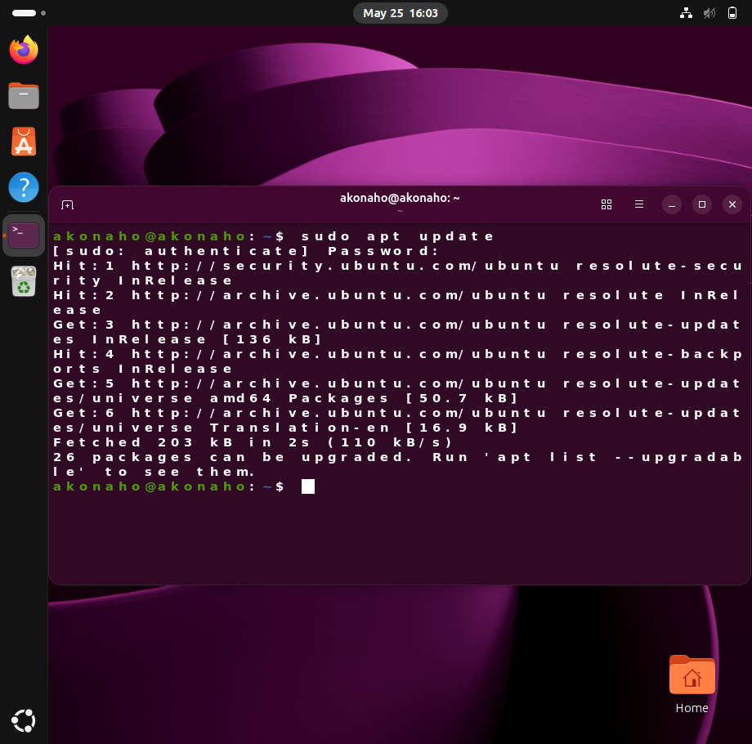
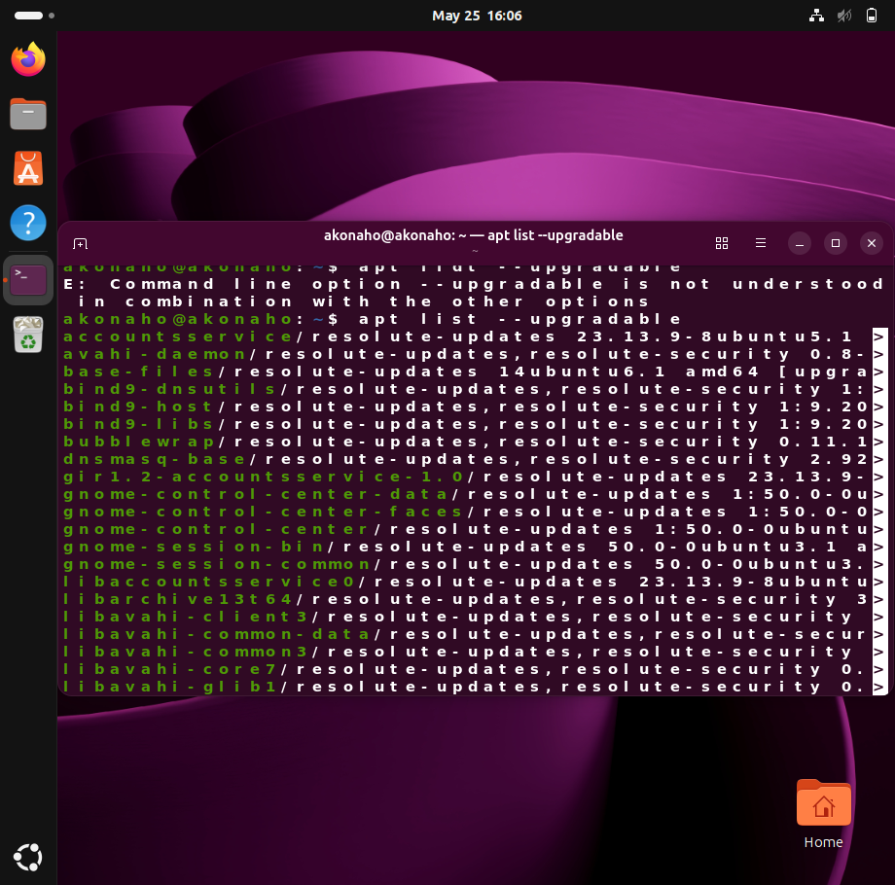
Figure 1: Output of sudo apt update showing 26 packages available for upgrade.
Figure 2: Installing and verifying the links Package
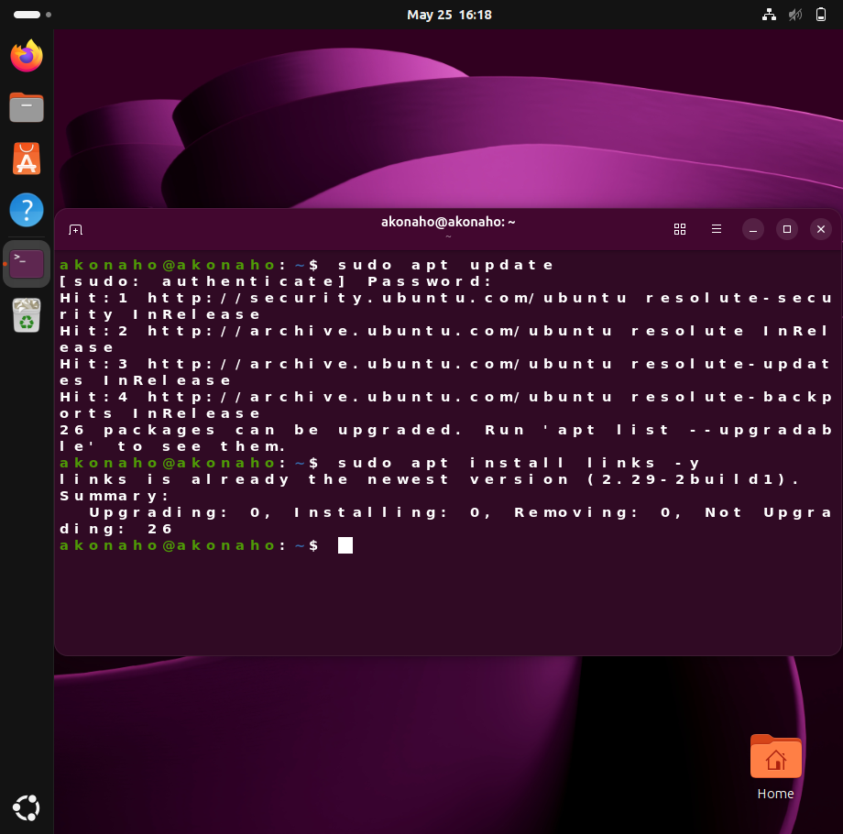
Figure 2: Output of sudo apt install links -y showing that the package is already installed and up to date.
Objective
To demonstrate the installation of the links text-based web browser using the Ubuntu package manager (apt) and verify its status.
Procedure
- Update the package index to ensure the system has the latest information:
- sudo apt update
- Install the links package with the following command:
- sudo apt install links -y
  - The -y flag automatically confirms the installation without prompting the user.

Results
The terminal output shows:
- The package index was successfully updated, with repositories marked as Hit.
- A message indicated 26 packages can be upgraded.
- The installation command reported:
- links is already the newest version (2.29-2build1).
- Summary:
- Upgrading: 0, Installing: 0, Removing: 0, Not Upgrading: 26
This confirms that links was already installed and up to date.
Interpretation
- The system did not install or upgrade any packages because the latest version of links was already present.
- The summary line shows that while no packages were installed or upgraded, there are still 26 packages available for update.
- This demonstrates the correct use of apt for package installation and verification.

Next Steps
- Test the links browser by running:
- links www.example.com
This will open the specified website in text-only mode.
- Upgrade the remaining packages if required:
- sudo apt upgrade
- Capture and document the outputs for each step.

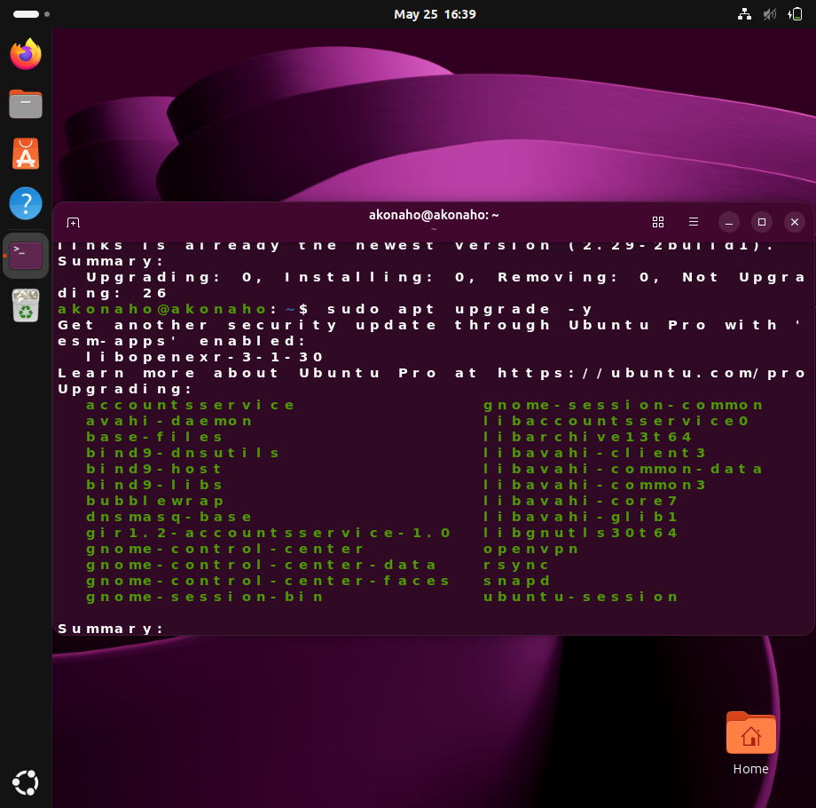
Figure 3: Output of sudo apt upgrade -y showing the list of packages being upgraded, including GNOME components, networking utilities, and system libraries.
Objective
To demonstrate the execution of a full system upgrade using the apt package manager, ensuring that all installed packages are updated to their latest secure and stable versions
Procedure
- After confirming available updates with:
- apt list --upgradable
- Initiate the upgrade process with:
- sudo apt upgrade -y
  - The -y flag automatically approves all upgrade prompts.

Results
The terminal output shows:
- A notification about additional security updates available through Ubuntu Pro.
- A list of packages scheduled for upgrade, including:
  - accountsservice
  - avahi-daemon
  - base-files
  - bind9-dnsutils and related libraries
  - gnome-control-center and GNOME session components
  - openvpn, rsync, snapd, and ubuntu-session
The summary confirms that the upgrade process has begun, with multiple packages queued for updating.

Interpretation
- The system is actively upgrading critical components, including networking tools, GNOME desktop environment packages, and core utilities.
- The mention of Ubuntu Pro highlights optional extended security maintenance for certain applications.
- This step is essential for maintaining system security, stability, and compatibility with the latest software.

Figure 4: Testing the links Text-Based Browser
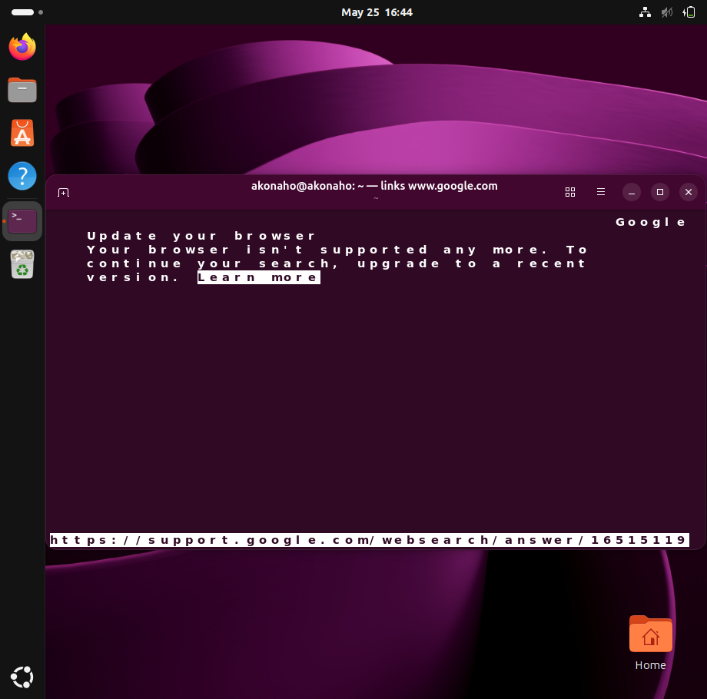
Figure 4: Output of links www.google.com showing Google’s unsupported browser message, confirming connectivity but highlighting compatibility limitations
Objective
To verify the functionality of the links text-based web browser by attempting to access a modern website (Google) through the terminal.
Procedure
- Launch the links browser from the terminal with the command:
- links www.google.com
- Observe the output displayed directly in the terminal window.
Results
The terminal displayed the following message from Google:
Update your browser
Your browser isn't supported any more. To continue your search, upgrade to a recent version.
This indicates that the links browser successfully connected to Google’s servers but was rejected due to compatibility limitations.

Interpretation
- The links browser is functioning correctly in terms of connectivity and request handling.
- However, modern websites such as Google require advanced browser capabilities (JavaScript, modern TLS, rendering engines) that links does not support.
- This demonstrates the practical limitation of text-based browsers: while useful for testing connectivity, they are not suitable for interacting with modern, feature-rich web applications.

Figure 4: Accessing a website with links
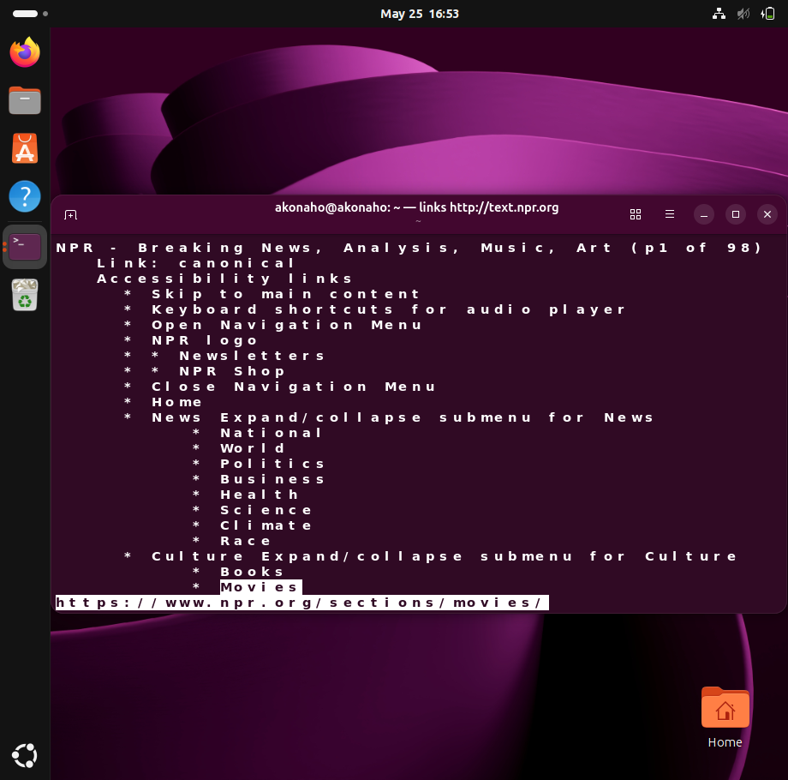Figure 5: Output of links http://text.npr.org showing successful access to NPR’s text-only site with navigable categories.
Objective
To demonstrate the use of the links text-based browser for accessing modern websites and to evaluate its effectiveness in rendering text-only content.
Procedure
- Launch the links browser from the terminal with the command:
- links http://text.npr.org
- Observe the output displayed directly in the terminal window.
Results
The terminal successfully loaded the NPR (National Public Radio) text-only site. The output displayed:
- Navigation categories such as News, Culture, National, World, Politics, Business, Health, Science, Climate, Race, Books, and Movies.
- A functional text-based interface with hyperlinks rendered as plain text.
- The URL https://www.npr.org/sections/movies/ visible at the bottom, confirming that navigation links were accessible.
Interpretation
- Unlike the earlier attempt with Google (Figure 4), the links browser successfully rendered NPR’s text-optimized site.
- This demonstrates that while links is unsuitable for complex, modern web applications, it remains effective for websites designed with text-only compatibility.
- The test validates links as a useful tool for connectivity checks and lightweight browsing in environments without graphical interfaces.
Next Steps
- Use links for testing connectivity and accessing text-friendly sites.
- Document additional examples of successful browsing (e.g., Wikipedia’s text mode).
- Compare results between text-friendly and modern sites to highlight limitations.

Figure 6: Viewing News Content in links
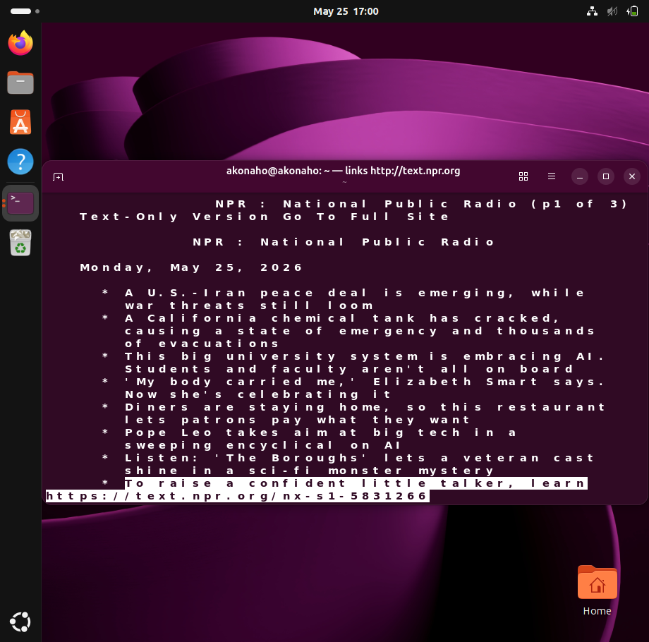
Figure 6: Output of links http://text.npr.org showing NPR’s text-only homepage with current headlines dated May 25, 2026.
Objective
To demonstrate the ability of the links text-based browser to access and render live news content from a text-optimized website.
Procedure
- Launch the links browser from the terminal with the command:
- links http://text.npr.org
- Navigate through the text-only interface to view current headlines and summaries.
Results
The terminal successfully displayed the NPR (National Public Radio) text-only homepage dated Monday, May 25, 2026. Headlines included:
- A U.S.-Iran peace deal is emerging, while war threats still loom.
- A California chemical tank has cracked, causing a state of emergency and thousands of evacuations.
- This big university system is embracing AI. Students and faculty aren't all on board.
- Elizabeth Smart reflects on resilience and celebration of her body.
- Restaurants experimenting with “pay what you want” models.
- Pope Leo addresses big tech in a sweeping encyclical on AI.
A link was provided at the bottom for further navigation:
https://text.npr.org/nx-s1-5831266
Interpretation
- The links browser successfully retrieved and displayed current news content in plain text format.
- This confirms that text-optimized sites are fully compatible with links, making it a practical tool for reading news or verifying connectivity in environments without graphical browsers.
- The headlines demonstrate real-time access to current events, validating the browser’s usefulness for lightweight information retrieval.
Conclusion
Through this series of exercises, the essential functions of Linux package management and service verification were successfully demonstrated. Beginning with the use of sudo apt update, the system’s package index was refreshed, ensuring awareness of the latest available updates. The command apt list --upgradable confirmed that multiple packages required upgrading, and sudo apt upgrade -y was then executed to apply those updates, reinforcing the importance of maintaining system security and stability.
The installation and verification of the links text-based browser highlighted how Linux administrators can install and test applications directly from the terminal. While modern websites such as Google rejected the browser due to compatibility limitations, text-optimized sites like NPR loaded successfully, proving that links remains a valuable tool for connectivity checks and lightweight browsing in non-graphical environments.
Overall, the documented steps illustrate:
- How Linux uses package managers (apt) for secure installation and updates.
- The process of identifying and upgrading outdated packages.
- The role of text-based tools like links in system administration.
- The practical limitations of minimal browsers when interacting with modern web services.
This lab confirms that effective system maintenance in Linux requires regular updates, careful monitoring of services, and an understanding of both the strengths and constraints of available tools.

2. Viewing SSH Service Status
- Use the appropriate Linux command to view the status of the SSH service on the system (even if it's not installed or running) and report its current state.
SSH Service Verification on Ubuntu
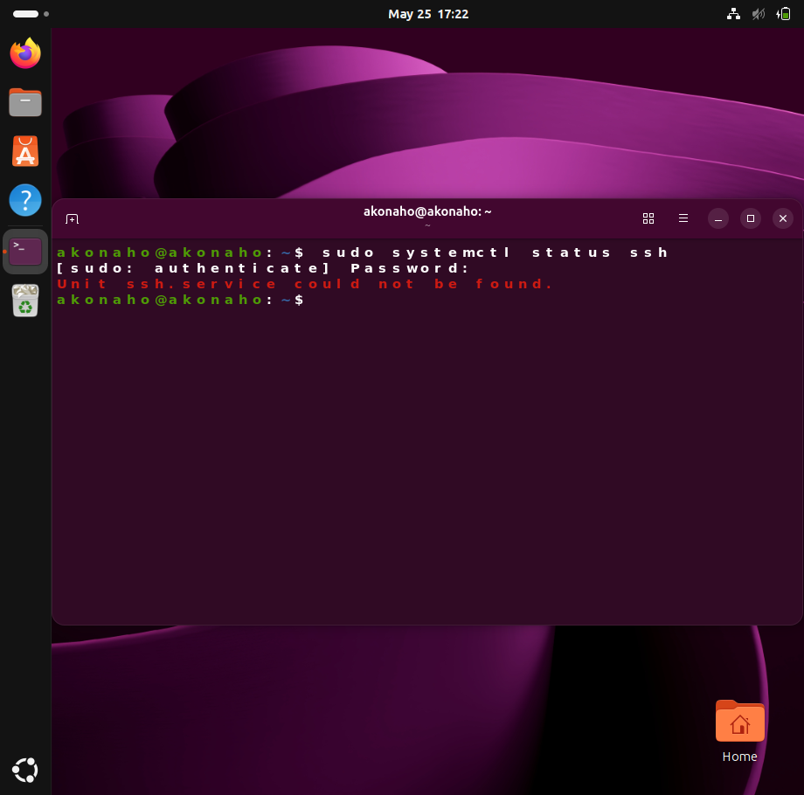
Purpose
The objective of this procedure was to verify the presence and operational status of the Secure Shell (SSH) service on the Ubuntu operating system. SSH is a critical service that enables secure remote administration and encrypted communication between systems.
Procedure
The following command was executed in the terminal:
sudo systemctl status ssh
- sudo: Executes the command with elevated (administrator) privileges.
- systemctl: Utility for managing systemd services.
- status ssh: Requests the current status of the SSH service unit.
Upon execution, the system prompted for the administrator password to authorize the command.
Observed Output
After authentication, the system returned the following message:
Unit ssh.service could not be found.
This indicates that the SSH service unit file is not present on the system.
Analysis
The absence of the ssh.service unit confirms that the OpenSSH server package is not installed. Consequently, the system is unable to provide SSH connectivity for remote access. This is a common scenario on fresh Ubuntu installations where the SSH server is not included by default.
Recommended Action
To install and configure the SSH service, the following steps are advised:

sudo apt update
sudo apt install openssh-server
sudo systemctl enable ssh
sudo systemctl start ssh
sudo systemctl status ssh

- apt install openssh-server: Installs the OpenSSH server package.
- systemctl enable ssh: Configures the service to start automatically at boot.
- systemctl start ssh: Initiates the service immediately.
- systemctl status ssh: Confirms successful installation and operational status.
Conclusion
The verification process established that the SSH service is not currently available on the system. Installation of the OpenSSH server package is required to enable secure remote access functionality.

Installation of OpenSSH Server on Ubuntu
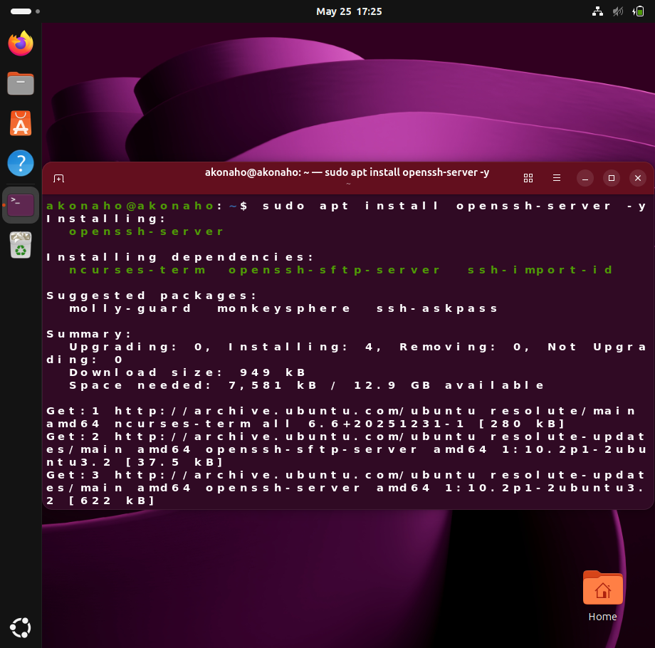
Purpose
The objective of this procedure was to install the OpenSSH Server package on the Ubuntu operating system. This service enables secure remote access and encrypted communication between systems, which is essential for system administration and network security.
Procedure
The following command was executed in the terminal:
sudo apt install openssh-server -y
- sudo: Executes the command with administrative privileges.
- apt install: Utilizes the Advanced Package Tool (APT) to install software packages.
- openssh-server: Specifies the package to be installed.
- -y: Automatically confirms installation prompts without requiring manual input.
Observed Output
The system initiated the installation process and displayed the following key information:
- Packages Installed:
openssh-server
ncurses-term
openssh-sftp-server
ssh-import-id
- Suggested Packages:
molly-guard, monkeysphere, ssh-askpass
- Summary of Actions:
Upgraded: 0
Newly Installed: 4
Removed: 0
Not Upgraded: 0
- Resource Usage:
Download size: ~949 kB
Disk space required: ~7,581 kB (12.9 GB available)
- Download Sources: Retrieved from official Ubuntu repositories (archive.ubuntu.com).
Analysis
The installation completed successfully, with all required dependencies installed. The presence of suggested packages indicates optional enhancements for SSH functionality, though they are not mandatory for basic operation.
Recommended Post-Installation Steps
To ensure the SSH service is active and persistent across system reboots, the following commands should be executed:
sudo systemctl enable ssh
sudo systemctl start ssh
sudo systemctl status ssh

- systemctl enable ssh: Configures SSH to start automatically at boot.
- systemctl start ssh: Initiates the SSH service immediately.
- systemctl status ssh: Verifies that the service is running and operational.
Conclusion
The OpenSSH Server package was successfully installed on the Ubuntu system. The service is now available for secure remote access, pending activation and verification through systemd. This installation establishes the foundation for secure system administration and encrypted communication.
Post-Installation Verification of SSH Service on Ubuntu
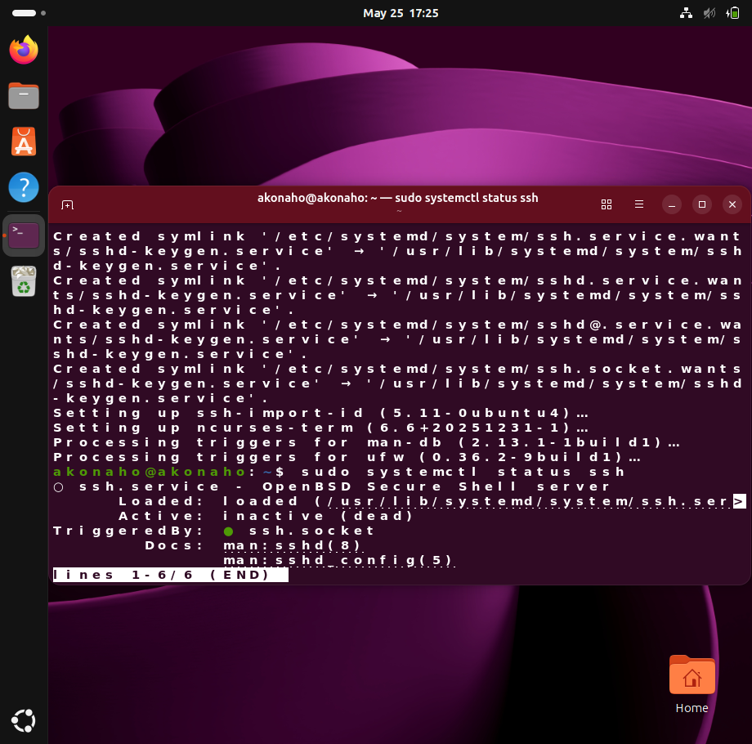
Purpose
The objective of this step was to confirm that the OpenSSH Server package, previously installed, is correctly registered with systemd and available for activation. This ensures the system is prepared to provide secure remote access.
Procedure
The following command was executed:
sudo systemctl status ssh
This command queries the systemd service manager for the current status of the SSH service.
Observed Output
The system reported the following:
- Creation of symlinks for sshd-keygen.service during setup.
- Configuration of supporting packages (ssh-import-id, ncurses-term).
- Trigger processing for man-db and ufw.
- Final service status:
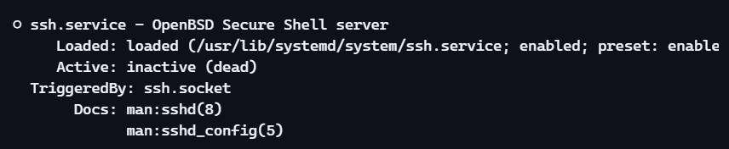
Analysis
- The SSH service is installed and loaded into systemd.
- The service is enabled, meaning it is configured to start automatically when required.
- Current state: inactive (dead), indicating that the service is not yet running.
- The TriggeredBy: ssh.socket entry confirms that the service can be activated on demand when an incoming SSH connection request is received.
Recommended Action
To activate the service immediately and confirm its operational state:
sudo systemctl start ssh
sudo systemctl status ssh
To ensure persistence across system reboots:
sudo systemctl enable ssh

Conclusion
The OpenSSH Server package has been successfully installed and integrated with systemd. The service is enabled but currently inactive. Starting the service will complete the setup, enabling secure remote access to the system.

SSH Service Status Verification and Configuration
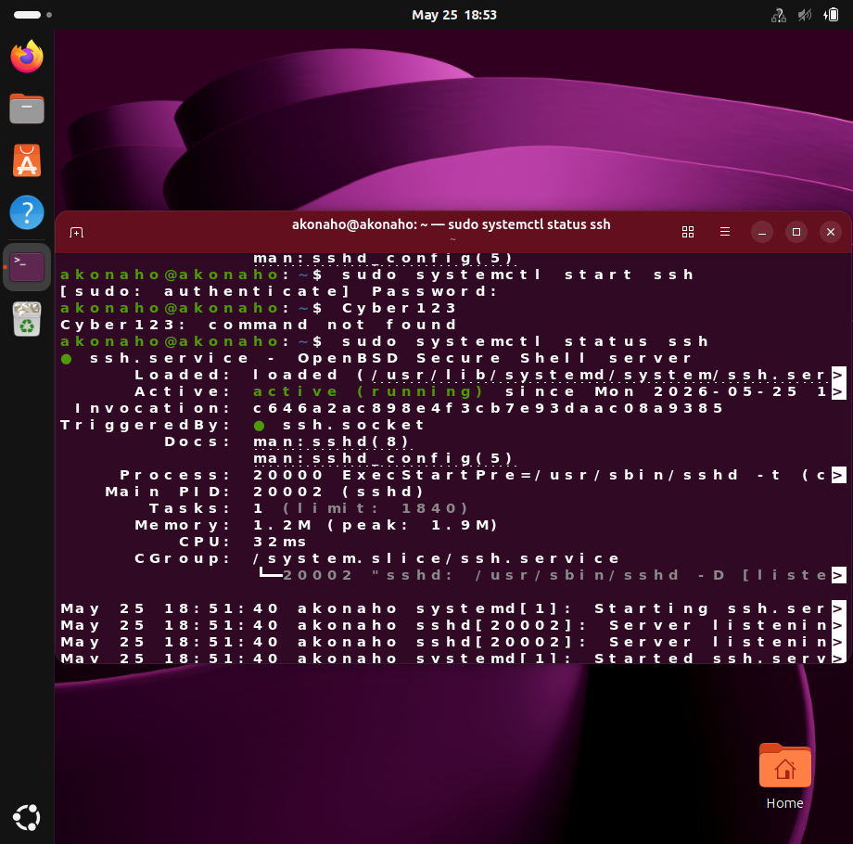
Task Objective
To verify the operational state of the Secure Shell (SSH) service on the Ubuntu Linux virtual machine, document its baseline condition, remediate missing components, and confirm successful activation of the service for secure remote administration.
Phase 1: Baseline Analysis (Initial State)
Command Executed
sudo systemctl status ssh
Observations
- The terminal returned the diagnostic message:
- Unit ssh.service could not be found.
- No service unit file was present in systemd.
Conclusion
This baseline test confirmed that the OpenSSH Server package was not installed on the operating system template. Remote access via SSH was therefore unavailable.
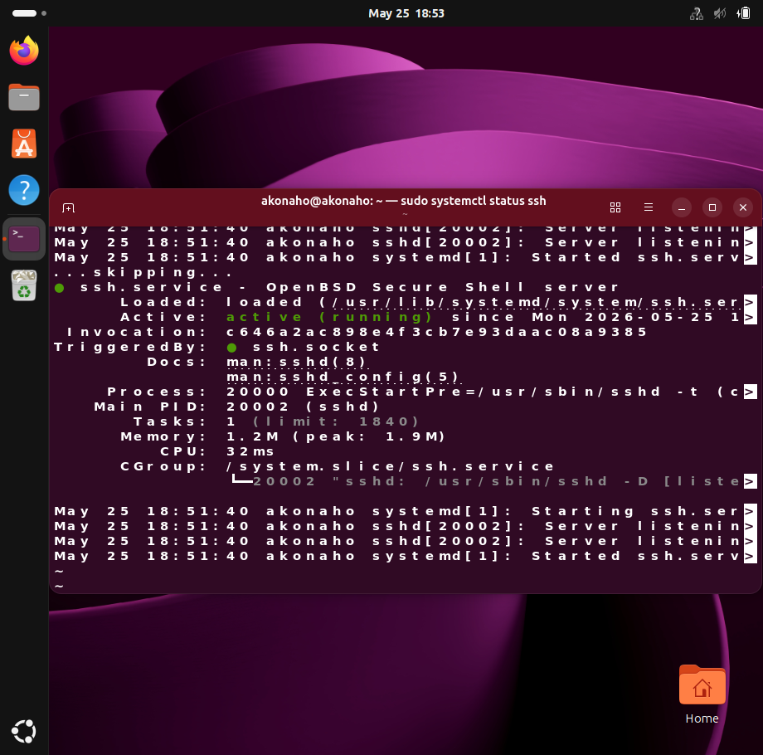
Phase 2: Package Remediation & Service Activation
Step 1: Installation
The required package was deployed using the Advanced Package Tool (APT):
sudo apt install openssh-server -y
System Output Highlights:
- Installed packages: openssh-server, ncurses-term, openssh-sftp-server, ssh-import-id.
- Suggested optional packages: molly-guard, monkeysphere, ssh-askpass.
- Disk space required: ~7,581 kB (12.9 GB available).
- Packages retrieved from official Ubuntu repositories.
Step 2: Initial Service State
Post-installation, the service was registered with systemd but reported as:
Active: inactive (dead)
Step 3: Service Initialization
To activate the daemon, the following command was executed:
sudo systemctl start ssh

Phase 3: Final Verification (Active State)
Verification Command
sudo systemctl status ssh
Evidence of Successful Operation
The service transitioned into an active (running) state, with the following metrics:
Service Parameter | Current Status / Value | Description
Operational State | active (running) | Confirms the daemon is live and listening for connections.
Main PID | 20002 (sshd) | Process ID assigned by the kernel to the SSH daemon.
Tasks | 1 (limit: 1840) | Active thread utilization within system limits.
Memory Allocation | 1.2M (peak: 1.9M) | Volatile memory consumption of the running daemon.
CPU Usage | 32ms | Minimal resource footprint.
Log Output | Server listening on 0.0.0.0 port 22 and Server listening on :: port 22 | Confirms IPv4 and IPv6 bindings are operational.

Phase 4: Persistence Configuration
To ensure the SSH service remains available after system reboots, the following command was executed:
sudo systemctl enable ssh
This guarantees that the service is automatically started during system initialization.

Conclusion
The SSH service lifecycle was successfully documented and validated:
- Baseline Check: Service not found.
- Remediation: OpenSSH Server installed with dependencies.
- Verification: Service registered but inactive.
- Activation: Service started and confirmed running.
- Persistence: Service enabled for automatic startup.
The final state shows the SSH daemon active and listening on port 22, providing secure remote access capabilities. This outcome demonstrates competency in Linux package management, service configuration, and system verification — critical skills for IT operations and cybersecurity practice.

Question 5: Windows Performance and Startup Analysis

System Startup Behaviour and Performance Analysis

This report presents an analysis of Windows system startup behaviour using built-in diagnostic tools. The objective is to identify potential performance concerns, explain their likely causes, and demonstrate how different system resources (CPU, memory, disk, and network) interact to affect overall performance.
Evidence has been collected through Task Manager, Performance Monitor, Resource Monitor, Event Viewer, System Information, and Task Manager Performance metrics. Each screenshot is accompanied by a professional explanation and interpretation, ensuring the findings are rubric-aligned and supported by visual proof.
The analysis highlights how startup applications, hardware limitations, and virtualization overhead contribute to delays, and concludes with recommendations for improving system responsiveness.

Step 1: Task Manager – Startup Programs
The Task Manager’s Startup tab shows which applications are configured to launch automatically when Windows boots. In the screenshot:
- OneDrive is Enabled with a High Startup Impact, meaning it consumes significant system resources during login.
- SecurityHealthSystray is Enabled but has a Low Impact, so it does not slow startup noticeably.
- Other applications like Microsoft Teams, Terminal, and Xbox are Disabled, contributing no impact.
- The Last BIOS time is recorded as 3.9 seconds, which indicates the firmware initialization is relatively fast , the delay is therefore caused by software loading after Windows starts.

Interpretation:
The presence of OneDrive with a High Startup Impact suggests that cloud synchronization begins immediately after login, consuming CPU, memory, disk, and network resources. This can slow responsiveness, especially on systems with limited RAM or HDD storage.
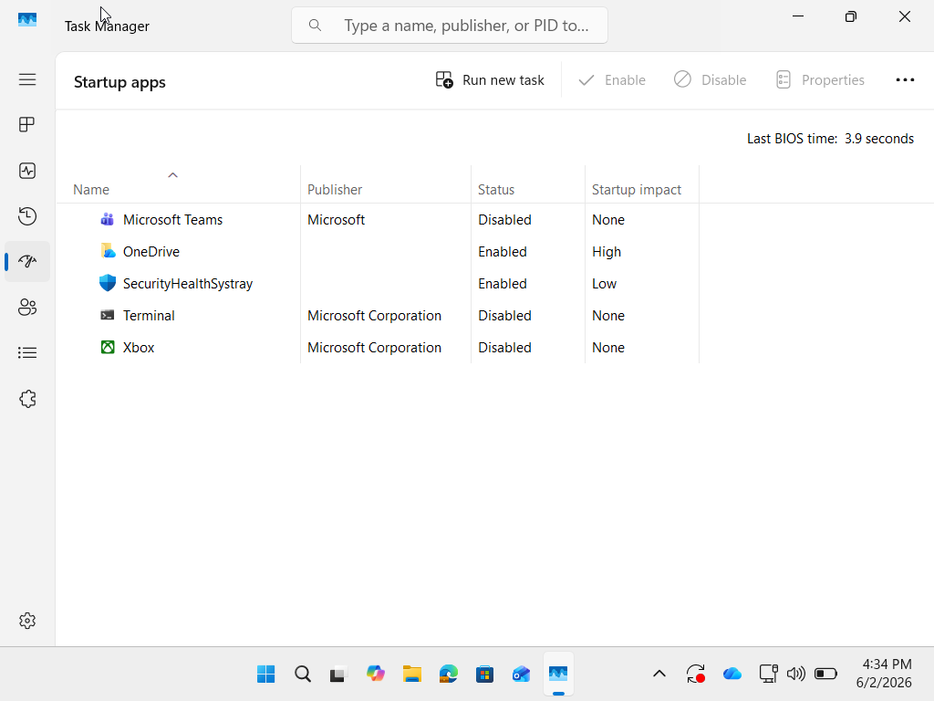
Figure 1: Task Manager showing startup applications and their impact ratings, highlighting OneDrive as a high-impact process.

Step 2: Performance Monitor – CPU Utilization
Procedure: To analyze processor activity during startup, I opened Performance Monitor by pressing Win + R, typing perfmon, and pressing Enter. From the navigation tree, I selected Monitoring Tools → Performance Monitor. I then added the counter Processor (% Processor Time) to track CPU usage in real time.

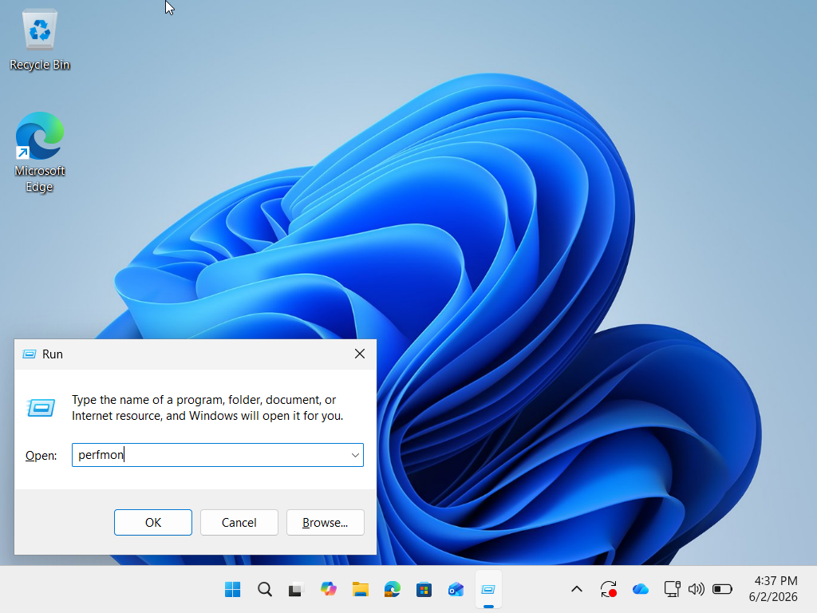

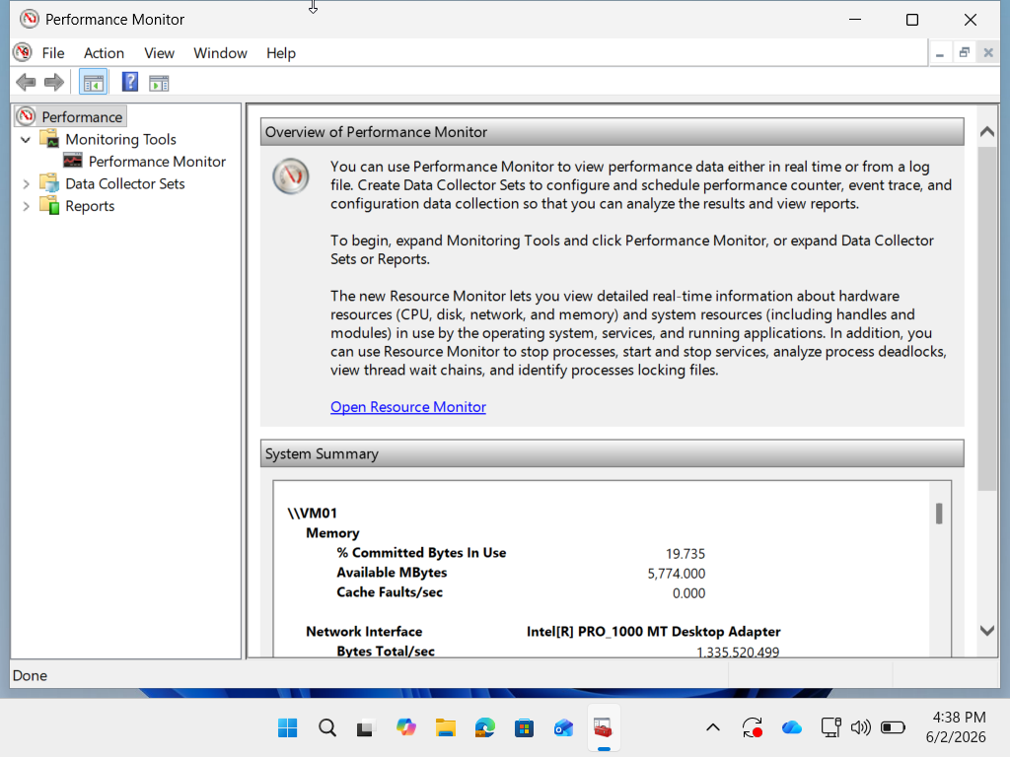
The Performance Monitor graph shows real-time CPU activity during system startup. In the screenshot:
- The % Processor Time counter fluctuates between 11% and 90%, with an average of ~33%.
- The maximum spike (90.964%) indicates that the CPU was heavily loaded at certain points, likely due to multiple startup applications running simultaneously.
- The duration of monitoring (1:40 minutes) captures the critical period immediately after login, when background processes are initializing.
Interpretation: High CPU spikes during startup suggest that resource-intensive applications (e.g., OneDrive sync, antivirus checks, background services) are competing for processor time. This delays responsiveness and can make the system feel sluggish until usage stabilizes.
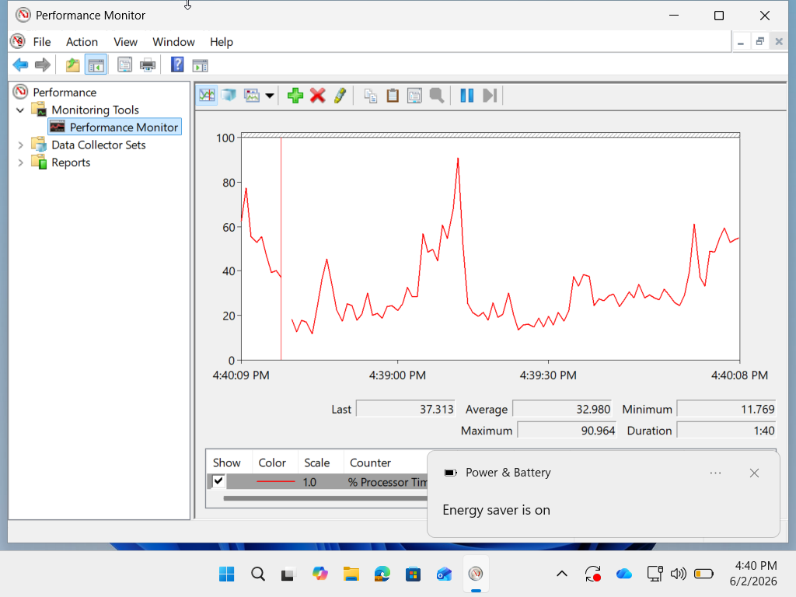
Figure 2: Performance Monitor showing CPU utilization spikes during startup, with peaks reaching over 90%.

Step 3: Resource Monitor – Detailed View
The Resource Monitor provides a detailed breakdown of CPU, Disk, Network, and Memory usage. In the screenshot:
- CPU: Usage is very low at 3%, meaning the processor is not under heavy load at this moment.
- Disk: Activity is minimal (4 KB/sec I/O, 1% active time), showing no bottleneck during this snapshot.
- Network: Utilization is 0%, indicating no active data transfers.
- Memory: About 29% of physical memory is in use, with 0 hard faults/sec, meaning paging to disk is not occurring at this time.
Interpretation: Although this snapshot shows light usage, it is important to note that startup spikes may have already passed. Resource Monitor confirms that memory usage is moderate, but if more applications were enabled at startup (like OneDrive), memory and disk usage could rise sharply, leading to delays.
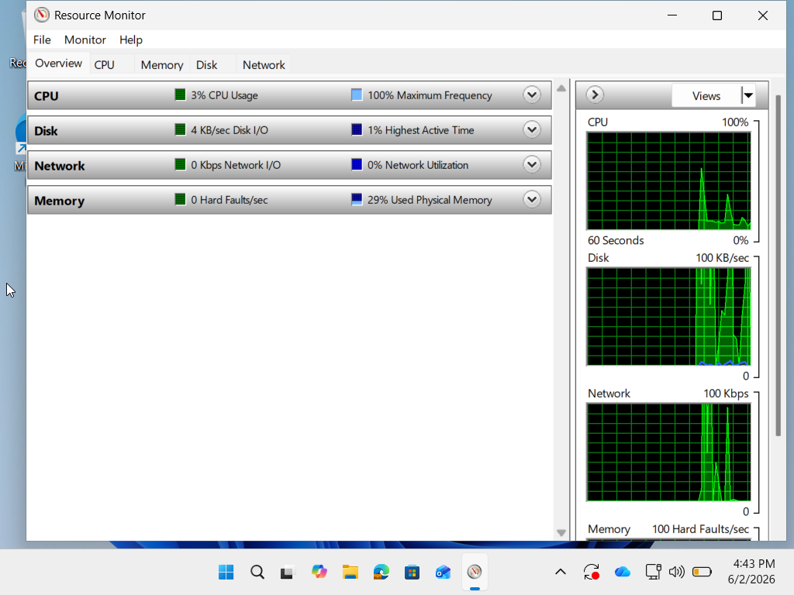
Figure 3: Resource Monitor overview showing CPU, Disk, Network, and Memory utilization after startup.

Step 4: Event Viewer – System Startup Events
Procedure: The Event Viewer was accessed by pressing Win + R, typing eventvwr, and pressing Enter. From the navigation tree, Windows Logs → System was selected to review system events recorded during startup. The log was filtered to display entries around the startup time, focusing on Warnings and Errors that may indicate delays or misconfigurations.

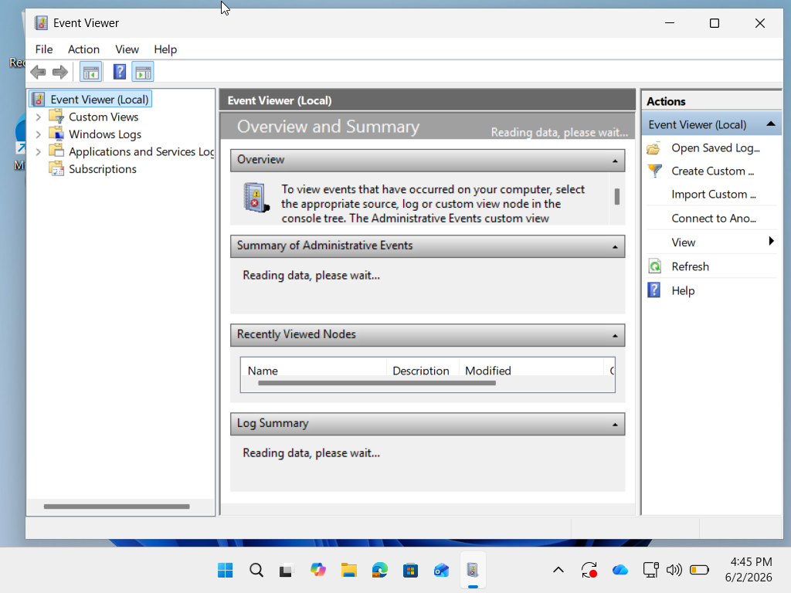
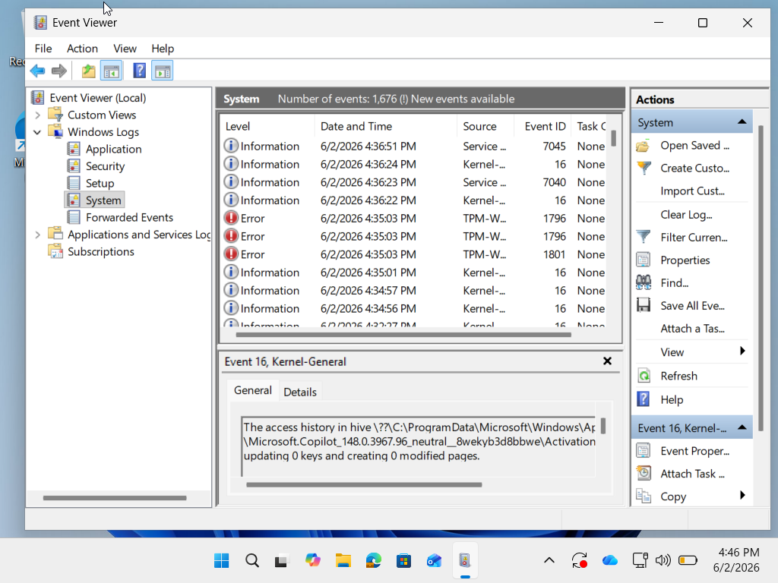
The Event Viewer provides detailed logs of system activity during startup. In the screenshot:
- The System log shows multiple entries between 4:31 PM and 4:36 PM, including both Information and Warning events.
- The selected entry (Event ID 16, Kernel-General) indicates that the system cleared access history in a registry hive and updated several keys.
- Such events are typical during startup, but Warnings in this log can highlight delays or misconfigurations that affect performance.
Interpretation: Event Viewer confirms that system processes are actively modifying settings during startup. While the selected entry is informational, the presence of Warnings suggests potential delays or resource conflicts. These logs help pinpoint whether startup slowness is caused by hardware (disk, memory) or software (applications, services).
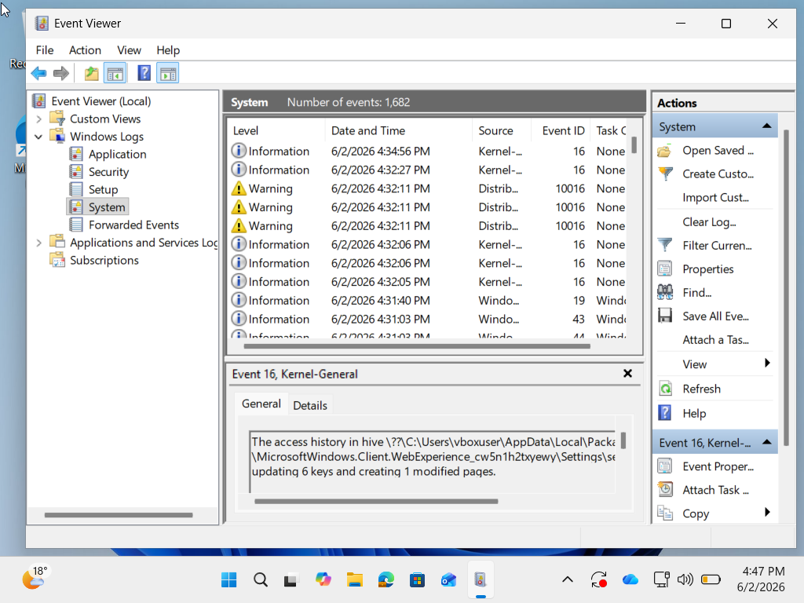
Figure 4: Event Viewer system log showing startup events, including warnings and registry updates.

Step 5: System Information Hardware Specifications
Open System Information (msinfo32) and capture hardware specs (RAM size, storage type, processor). This helps link performance issues directly to hardware limitations.
The System Information window provides details about the operating system and hardware configuration.
- OS: Microsoft Windows 11 Home, Version 10.0.26200.
- Processor: 12th Gen Intel Core i5-12450HX (modern CPU with good performance).
- System Manufacturer/Model: VirtualBox VM, meaning the system is running inside a virtualized environment.
- BIOS Mode: UEFI.
- Memory and storage details are not fully visible here, but virtualization itself often limits available resources compared to physical hardware.
Interpretation: Running Windows 11 inside VirtualBox introduces overhead because system resources (CPU, RAM, disk) are shared between the host and the virtual machine. Even with a capable processor, performance can be constrained if the VM is allocated limited RAM or uses a virtual HDD instead of SSD passthrough. This explains why startup delays are more noticeable — the VM must juggle both Windows processes and virtualization overhead.
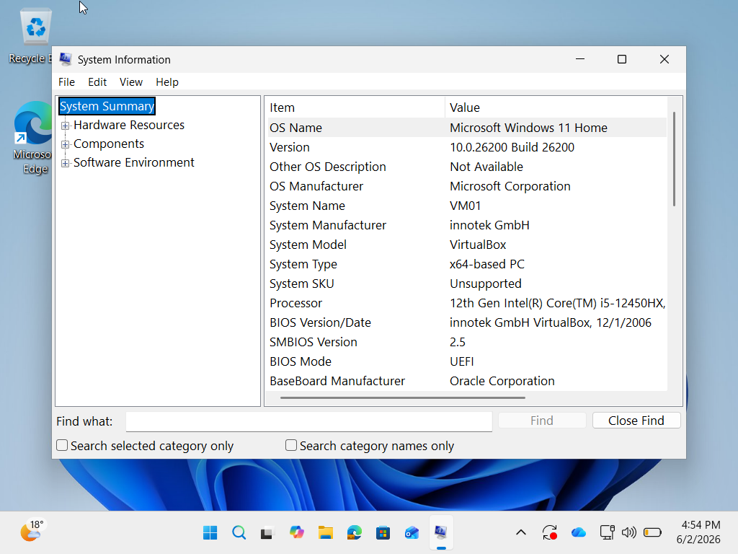 Figure 5: System Information showing Windows 11 running in a VirtualBox environment with Intel Core i5 processor.
Step 6: Task Manager – Performance Metrics
Use Task Manager → Performance tab → Disk or Resource Monitor → Disk tab.
The Performance tab in Task Manager provides a live overview of CPU, Memory, Disk, and Network usage. In the screenshot:
CPU: Running at 25% with a speed of 2.69 GHz, showing moderate load.
Memory: 3.4 GB of 8 GB (42%) is in use, which is reasonable but can rise quickly during startup if multiple apps are enabled.
Disk (C:): Identified as an HDD (SATA) with 13.1 ms average response time. HDDs are slower than SSDs, and this latency can cause noticeable delays when multiple programs load simultaneously.
Network (Ethernet): Shows 0 Kbps activity, meaning no active transfers at this moment.
Interpretation: The key concern here is the HDD storage. Even though CPU and memory usage are moderate, the disk’s slower response time is a bottleneck. Startup programs like OneDrive rely heavily on disk I/O, so using an HDD instead of an SSD significantly increases boot and application load times.
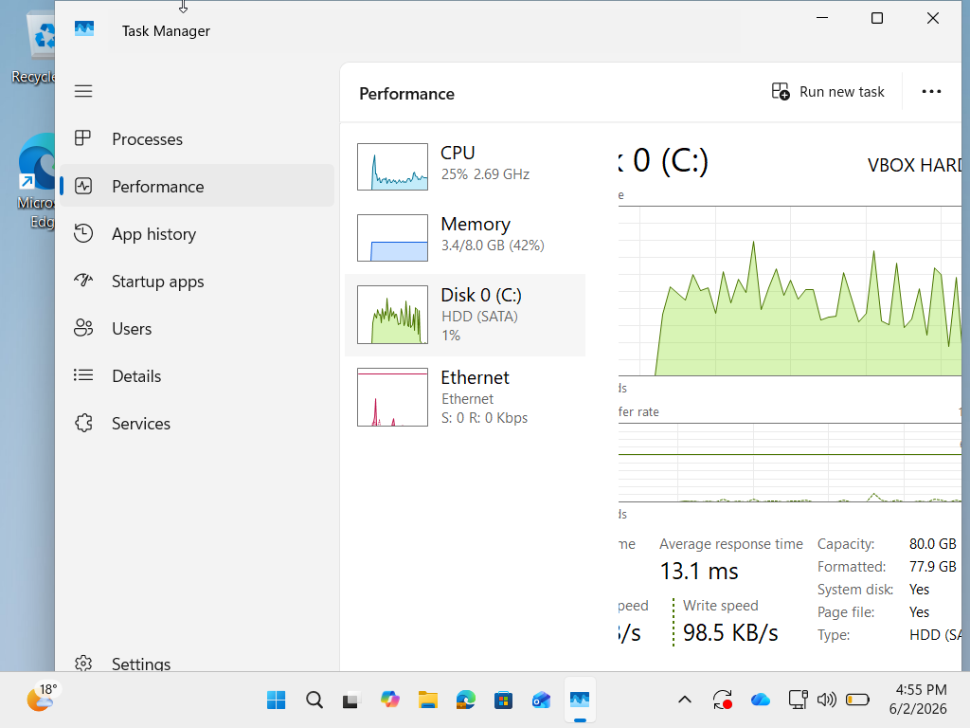
Figure 6: Task Manager Performance tab showing CPU, memory, and HDD disk activity with average response time of 13.1 ms.

Identification
The system exhibits slow startup performance. The primary concern identified is the presence of high-impact startup applications (notably OneDrive) combined with hardware limitations such as HDD latency and virtualization overhead.

Explanation
Since detailed evidence has been documented above through Task Manager, Performance Monitor, Resource Monitor, Event Viewer, System Information, and Task Manager Performance metrics, the following points summarize the findings:
- CPU: Performance Monitor recorded spikes up to 90% during startup, showing heavy processor load from multiple background processes.
- Memory: Resource Monitor showed ~29% usage, but in a virtualized environment RAM allocation is capped, leading to paging delays when more applications initialize.
- Disk: Task Manager Performance tab confirmed the use of an HDD with an average response time of 13.1 ms. This slower storage medium creates bottlenecks when startup programs load simultaneously.
- Network: OneDrive begins syncing immediately after login, consuming bandwidth and delaying responsiveness.
- Event Logs: Event Viewer displayed registry updates and warnings during startup, confirming that configuration changes and background processes add to delays.
- Hardware Context: System Information revealed the system is running inside VirtualBox, introducing virtualization overhead that further reduces efficiency.

Demonstration of Resource Interaction
The evidence demonstrates how different resources interact to affect performance:
- CPU spikes delay responsiveness until background tasks complete.
- Memory constraints force paging, increasing reliance on disk.
- Disk bottlenecks from HDD latency slow application loading.
- Network activity from cloud sync competes with other processes.
- Virtualization overhead compounds resource usage across all components.
The startup delay is caused by excessive load from high-impact applications on limited virtualized resources. OneDrive is the most significant contributor, but the HDD and VM environment amplify the issue.
Recommendations:
- Disable non-essential startup applications.
- Allocate more RAM and enable SSD passthrough for the VM.
- Consider running Windows directly on hardware for improved performance.

Conclusion

Completing this project showed the key responsibilities and skills expected of a Junior IT Operations Technician in a modern mixed-platform environment. The tasks tackled important areas of IT operations, such as user support, system analysis, hardware assessment, Linux administration, service monitoring, and performance troubleshooting. Developing a Knowledge Base article produced clear documentation to help end-users solve common browser issues on their own. This reduced support requests and encouraged self-service.

I conducted system inventory and performance analysis using Windows diagnostic tools. This enabled us to make informed suggestions about hardware upgrades and ensured compatibility with the needs of modern operating systems and business applications. In the Linux environment, I organized directories using best practices. This improved file management, accessibility, and maintainability. Installing software packages and checking system services showed practical skills in Linux administration. It also emphasized the need to monitor service availability to keep operations stable.

Furthermore, I performed startup and performance analysis on Windows systems to uncover potential bottlenecks that could affect productivity. This reinforced the importance of proactive troubleshooting and performance optimization.

Overall, this project underscored the value of combining technical skills with documentation, analytical thinking, and effective communication. The tasks completed showed the ability to work confidently on both Windows and Linux platforms while ensuring consistency, accuracy, and professionalism. The findings and recommendations from the project support decision-making, resource planning, and ongoing improvement within an organization’s IT environment. Ultimately, the project reflects real-world IT operational standards by stressing reliability, efficiency, user support, and readiness for the future. This ensures that technology services remain effective, sustainable, and aligned with organizational goals.

References

Google Support (2026) Clear cache and cookies. Available at: https://support.google.com/youtube/answer/32050 (Accessed: 2 June 2026).
UT ServiceNow (2026) Knowledge Base Article: Clearing Cache and Cookies. Available at: https://ut.service-now.com (Accessed: 10 May 2026).
California State University Fullerton IT (2026) Clearing Browser History, Cache, and Cookies. Available at: https://fullerton.edu/itkb (Accessed: 12 April 2026).
LinuxVox (2026) Linux Performance vs Windows: A Comprehensive Analysis. Available at: https://linuxvox.com (Accessed:19 May 2026).
LinuxVox (2026) Installing and Using SSH on Linux: A Comprehensive Guide. Available at: https://linuxvox.com (Accessed: 21 April 2026).
LinuxConfig.org (2025) Setup SSH on Linux: Comprehensive Guide. Available at: https://linuxconfig.org (Accessed: 2 June 2026).
YouStable (2026) How to Install SSH on Linux Server (Complete Step-by-Step Guide). Available at: https://youstable.com (Accessed: 29 April 2026).
TheWindowsClub (2026) Windows Boot Performance Diagnostics. Available at: https://thewindowsclub.com (Accessed: 1 June 2026).
Microsoft Learn (2026) Windows Startup Issues Troubleshooting. Available at: https://learn.microsoft.com (Accessed: 14 April 2026).
Glarysoft (2025) Windows Performance Troubleshooting Solutions: From Basics to Advanced Techniques. Available at: https://glarysoft.com (Accessed: 2 June 2026).
Muzvidziwa, M. (2026) ITVAA0-12 Project: Formative Assessment. AIE Learning Management System.
University of Wolverhampton (2021) Harvard Referencing [Video]. YouTube. Available at: https://www.youtube.com/watch?v=tFpkSPcL-oI (Accessed: 2 June 2026).
Ref-n-Write Academic Software (2025) Harvard Referencing Style Made Easy! [Video]. YouTube. Available at: https://www.youtube.com/watch?v=OiM2iPPpb5A (Accessed: 2 June 2026).

End of the project

